|  |  |  |  |  |  |  |  |  |  |  |  |  |  |  |  |  |  |  |  |  |  |  |  |  |  |  |  |  |  |  |  |  |  |  |  |
| --- | --- | --- | --- | --- | --- | --- | --- | --- | --- | --- | --- | --- | --- | --- | --- | --- | --- | --- | --- | --- | --- | --- | --- | --- | --- | --- | --- | --- | --- | --- | --- | --- | --- | --- | --- |
| |  |  |  | | --- | --- | --- | |  | **ÇANKAYA UNIVERSITY**  **MULTIDISIPLANARY PROJECT**  **(Mechanical and Computer Engineering Departments)** |  |   **ME408 PROJECT REPORT**   |  |  |  |  | | --- | --- | --- | --- | | **TITLE OF THE PROJECT:** | | | | | Foam Cutting Machine | | | | | **DATE:** | | 23/01/2021 | | | **TEAM MEMBERS:** | | | **ID NUMBERS:** | | **1** | Hanife SANCAR | | 201415208 | | **2** | Mert Eren ESER | | 201515018 | | **3** | Muhammet KOÇ | | 201515029 | | **4** | Doğukan KARATOP | | 201211030 |   ME408 Innovative Engineering Analysis and Design |

# Table of Contents

Table of Contents i

List of Figures iii

List of Tables iv

Abstract 1

1. INTRODUCTION 1

Work Planning 1

1.1. Problem Definition and Design Specification 2

1.2. Literature Review 9

1.2.1. Patents 9

1.3. Conceptual Design 10

1.3.1. First Project 10

1.3.2. Second Project 11

1.3.3. Third Project 11

1.3.4. Last Project 12

1.4. Design Route Map 13

2. DETAILED DESIGN 14

2.1. Sub-System of the Design 14

2.1.1. Motion System 14

2.1.2. Cutting System 16

2.1.3. Structure 17

2.1.4. Software 18

2.1.4.1. WHY ARDUINO UNO? 18

2.1.4.2. GRBL Ardunio Library 19

2.1.4.3. Universal G-Code Sender 19

2.1.4.4. INKSCAPE G-Code Generator 20

2.2. Analysis of the Design 21

2.3. Virtual Model of the Design 22

3. CONCLUSION and DISCUSSION 23

4. REFERANCESES 24

5. LITERATURE SURVEY 25

6. APPENDICES 27

6.1. APPENDIX A: Patent Figures 27

6.2. APPENDIX B: Technical Drawings 37

# List of Figures

Figure 1.Two Axis of CNC Machine and Effects 10

Figure 2. Three Axis of CNC Machine 11

Figure 3a)Four-Axis of CNC Machine 11

Figure 3b)Complex Design 11

Figure 4 8-Axis CNC Hot Wire Machine 12

Figure 5 Operation Process Chart 13

Figure 6 Y-Axis Motion 14

Figure 7 Y and Z-Axis Motion 15

Figure 8 Rotating Motion 15

Figure 9 Z-Axis Motion and Cutting Wire 16

Figure 10 Foam Cutting Structure 17

Figure 11 Temperature versus Distance Graph 19

Figure 12 Worm screw measurement 24

Figure 13 Hand Drawings 26

Figure 14a) Old version b)New verion 27

Figure 15 Ardunio UNO 28

Figure 16 Universal G-Code Sender 29

Figure 17 30

Figure 18 31

Figure 19 32

Figure 20 33

Figure 21 34

Figure 22 Hot Wire Stress Analysis 35

Figure 23 Foam Machine Virtual Model 36

Figure 24 US3757617A’Foam Cutting Apparatus’ 43

Figure 25 US4601224A’Hot Wire Cutting System’ 45

Figure 26 2007/04961’CNC Foam Cutting Machine’ 48

Figure 27 EP2402125A1’Method of Producing Test Component by Hot Wire Cutter’ 51

Figure 28 Foam Machine Technical Drawings 53

# List of Tables

Table 1.Shape Characterization 3

Table 2.Motion Classification 4

Table 3.Cutting Material Classification 4

Table 4.Actuator Classification 5

Table 5a.Design Specification 6

Table 5b.Design Specification 7

Table 5c.Design Specification 8

Table 6.Linear bearing measurements 24



………………………………

……………………………….

………………………………

……………………………

# Abstract

This report includes the document that studied within the aim of ME407 project. This report is explained under 3 main headings. These are literature survey, problem definition and design. First of all, literature survey had been done, keywords were identified, and similar projects were searched. In the second part, requirements and constrain were identified. In last part, analytic and numerical calculations were done. The solutions which are analytic and numerical were compared each other.

# INTRODUCTION

Foam material is used in flat-plate collector, automobile, building design, aircraft, sculpture, air conditioning (tornado), advertising (sign board, name plate for firm or factories), art design (wall decoration), producing model and prototype in engineering areas. The characteristics of this material are lightweight. Also cutting process is short time. It can be used at high cutting temperature and it is cheaper than the other materials. This report relates to the production of foam cutting machine. The foam material, which is very high in its usage area, contains all the procedures required to design a machine that can cut 2D and 3D. The programs we use to design this machine are as follows: Autocad Inventor, 3D Max, Ansys, Matlab and UGS. Moreover, we were preferred of the FANUC Program Language and codes in terms of infrastructures because FANUC Controls are more powerful, faster, and easier to use according to other program languages.

## Work Planning

* All work had been done together but each parts of work has coordinator these are;
* Literature survey and Problem Definition
* Material selection and Manufacturing
* Program Calculation
* Computer-Aided Control and Codes

## Problem Definition and Design Specification

* + 1. **Design Requirements**

When developing a useful product, it is necessary to take into account a number of elements. For example, forces, shape, material, work safety, efficiency, ease of use, budget, maintenance, sensors etc. Our priority has been occupational safety, as it is the question of people and operator use. Then our priority was efficiency, costs and maintenance. Our goal was that even the person who had no knowledge of the machine could use it like a specialist. If the product is positioned in a closed environment, it is necessary to use aerating fan to prevent the fumes released during the process from preventing the operator or other creatures. There are also several other security measures, safe working area, motion sensor, emergency button etc. Standard safety measures must also be taken during the process! Such as safety glasses, work gloves, hard hat and steel toe shoes. The product's maintenance procedure is negligible, except for heater wire breakage and work area cleaning. We mentioned that the subject we will stand out among the competitors is safety and efficiency, at the same time we kept the cost at the lowest level, almost 1/4 rate. We preferred a medium-sized geometry in the design so that we could shape products of many sizes, small and large. We also included options such as painting and solid model scanner in line with user requests. In addition to our preliminary design, we will present the design definitions that we foreseen below.

* + 1. **System Requirements**
* Plastic (3D Printer) and metal to be chosen for easy installation and cost.
* Aluminum sigma profiles will be used to create the framework for adjustable, lightweight and easy installation.
* Stepper motor will be used because precise position and speed control provides high torque needs at low rpm.
* EPP, EPS, XPS materials can be cut and the maximum temperature will be 164.5 ° C. The advance in the axes is 1mm, but the amount of advance can be changed by microcontrols or controls.
* Arduino UNO was chosen, which can meet the offered solutions and extras.
* CNC hot wire foam cutter machine will work with 12v power.
* For cost and maintenance reasons, the belt will be used for movement transfer.
* Nichrome wire, which meets strength and long life, was preferred.
* The control panel of the system will be managed externally with the help of a computer.
* The work lamp that provides information about the status of the job and the motion sensor will be used as a safety factor.
* The resolution is 0.1mm for optimum precision machining.
* 2.5D and various 3D products can be produced in this machine. (Excluding globe)
  + 1. **User Interface Requirements**
* For the comfort of users of all ages, easy use, ready codes and simple installation will be kept in the foreground.
* Extra paint spray and filter fan kit equipment will be offered in the system.

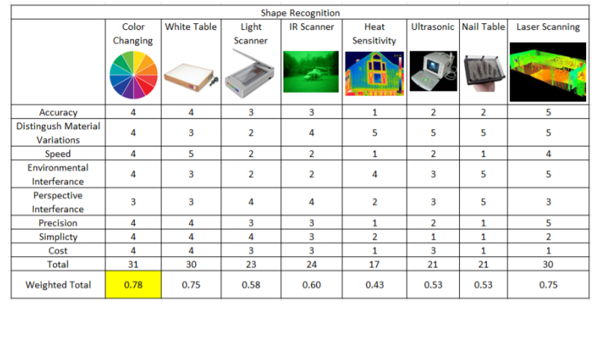

Table 1 Shape Characterization

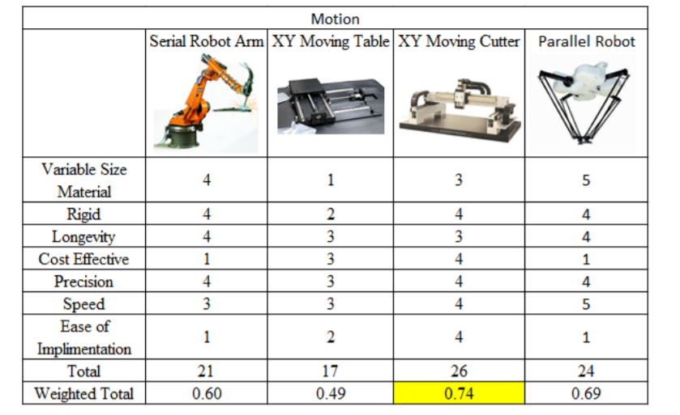

Table 2 Motion Classification

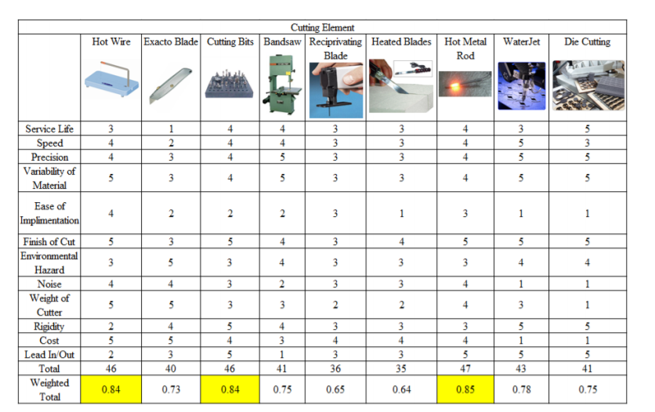

Table 3 Cutting Material Classification

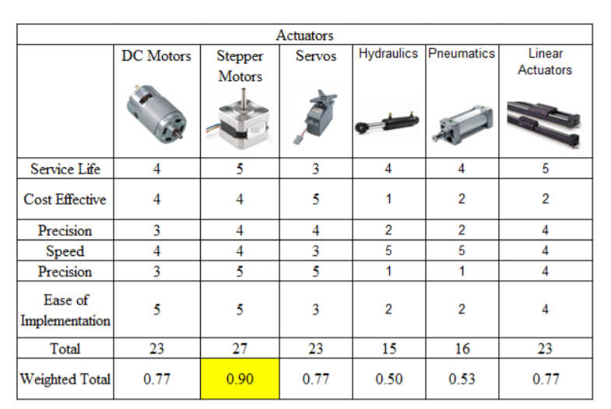

Table 4 Actuator Classification

|  |  |  |  |  |
| --- | --- | --- | --- | --- |
|  | Option 1 | Option 2 | Option 3 |  |
| **Table Types** | WOOD | PLASTIC✓ | METAL✓ | ▪ Plastic (3D Printer) and metal to be chosen for easy installation and cost. |
| **Material Types** | Çelik nedir |  STEEL | Physical Properties of Wood - Designing Buildings Wiki  WOOD | Amazon.com: 80/20 Inc, 1010, 10 Series, 1 Inch x 1 Inch Extrusion ...  ALUMINUM✓ | ▪ Aluminum sigma profiles will be used to create the framework for adjustable, lightweight and easy installation. |
| **Motor Types** | STEPPER MOTOR✓ | Tower Pro SG90 RC Mini Servo Motor | SAMM Market  SERVO MOTOR | DC MOTOR | ▪ Stepper motor will be used because precise position and speed control provides high torque needs at low rpm. |
| **Foam Types** | Polystyrene Foam 24"x48" Single | Foam Factory, Inc.  POLYSTRENE✓ | Strafor Mantolama Nedir?, Köpük Mantolama Nedir? | Metpor  STYROPOR✓ | Polietilen Köpük Ambalaj Levhaları  POLYTHENE | ▪ EPP, EPS, XPS materials can be cut and the maximum temperature will be 164.5 ° C. The advance in the axes is 1mm, but the amount of advance can be changed by microcontrols or controls. |
| **Arduino types** | Arduino Micro • elektromanyetix  MICRO | Orijinal Arduino UNO R3 Satın Al | Robotistan.com  UNO✓ | ARDUİNO,MEGA,arduino,mega,r3 I I 82,60 TL  MEGA | ▪ Arduino UNO was chosen, which can meet the offered solutions and extras. |
| **Power Types** | DC (12V) | AC✓ |  | ▪ CNC hot wire foam cutter machine will work with 12v power. |
| **Motion Types** | Pin by amgqed on 2017 Theme: Chain Reaction | Roller chain, Chain ...  CHAIN | Timing Belts | Dayco  BELT✓ | Rack Pinions at Rs 4500 /meter | George Town | Chennai | ID ...  GEARS | ▪ For cost and maintenance reasons, the belt will be used for movement transfer. |

Table 5a) Design Specification

|  |  |  |  |  |
| --- | --- | --- | --- | --- |
| **Wire Types** | Paslanmaz Çelik Tel // 1Metre  STAINLESS STEEL | Nichrome Wire – RPM Supplies  NICHROME✓ | Metalal.net | Online Metal Tedarikçiniz  COPPER | ▪ Nichrome wire, which meets strength and long life, was preferred. |
| **Control Panel** | Laptop - Vatan Bilgisayar  COMPUTER✓ | Kablolu El Çarkı – 4 eksen | Poysan Otomasyon  REMOTE CONTROLLER | Industrial IoT meets the iPhone and iPad in new GE/Apple deal ...  IOT | ▪ The control panel of the system will be managed externally with the help of a computer. |
| **Security** | China Lighting Industry Manufacturers Directory & Products on GILE ...  LIGHT | Lock Icon Security Padlock Locked Unlocked Stok Vektör (Telifsiz ...  LOCK | Arduino motion čídlo | arduino-shop.eu  MOTION SENSOR✓ | ▪ The work lamp that provides information about the status of the job and the motion sensor will be used as a safety factor. |
| **Resolution** | Mekanik Kumpas 150 mm Fiyatı, Taksit Seçenekleri ile Satın Al  0,1mm✓ | Mekanik Kumpas 150 mm Fiyatı, Taksit Seçenekleri ile Satın Al  0,5mm | Mekanik Kumpas 150 mm Fiyatı, Taksit Seçenekleri ile Satın Al  0.05mm | ▪ The resolution is 0.1mm for optimum precision machining. |
| **Products** | Letter A / 36daysoftype by Aleksandar Dumic on Dribbble  2D | 2.5D | Satranç Taşı (Şah) | Tinkercad  3D✓ | ▪ 2D, 2.5D and various 3D products can be produced in this machine. (Excluding globe) |
| **User Interface** | Arrows buttons keyboard Royalty Free Vector Image  EASY to USE✓ | Üçgen, Kare, Dikdörtgen Test 1 | İlköğretim Online Test Çöz  READY to CODES | easy to install vector icon isolated on transparent background ...  FILTER FAN KITS | ▪ For the comfort of users of all ages, easy use, ready codes and simple installation will be kept in the foreground. |

Table 5b) Design Specification

## Literature Review

**Key words:** EPS types, CNC Hot Wire Cutting, Hot Wire Cutting Types, Numerical Control and Analysis, Computer-Aided Control Mechanism and Codes.

In the literature research, previous projects and where they are used are searched, and then related articles were examined. We then found that the use of EPS, EPP, and XPS materials was convenient, paying attention to the frequency and suitability of the foam material we will use for cutting. We found that the use of NiCr(A) and NiCr(C) is appropriate for the thermal conductivity coefficient and cutting roughness in the selection of wires for foam cutting operation. We have also taken the decision to use the spring to ensure proper tension in the wire section. FANUC code programs from computer-aided programs used for computer-aided control have been our preferred reason for the convenience of the user. We thought of mounting with sigma profiles for the cage in machine design. We will also produce most necessary parts ourselves with the use of 3D printers. This will give us an advantage in making our machine light and portable. Mobility can be controlled with micro control and switch systems.

### **Patents**

* US3757617A- At 1973, John A. Fabbri was invented “Foam Cutting Apparatus” which has 2 axis [A].
* US4601224A- At 1986, William T. Clack, III was invented “Hot Wire Cutting System” which has 2 axis [B].
* 2007/04961- At 2007, Güç Makine Elektrik Elektronik San. Tic. LTD. ŞTİ. was invented “CNC Foam Cutting Machine” which has 3 axis [C].
* EP2402125A1- At Jason Stege was invented “Method of Producing Test Components by a Hot Wire Cutter” which has 3 axis [D].

## Conceptual Design

There are many different projects about hot wire cutting. These are ‘’Optimization the Parameters of Hot-wire CNC Machine’’ [11], ‘’CNC Foam Cutting Machine’’ [22], ‘’ Four Axis Hot-Wire Foam Cutter Controlled by Mindstorms EV3” [33], and “Rough Machining Process and Its Simulation for Robot Integrated Surface Sculpturing System Design ’’ [44].

### **First Project**

### First project is Optimization the Parameters of Hot-wire CNC Machine. This project is designed in two dimensions depending on the diameter, material and temperature of the cutting wire. The intensity of cutting speed and foam was determined by the change of parameters such as optimum temperature, suitable wire diameter.

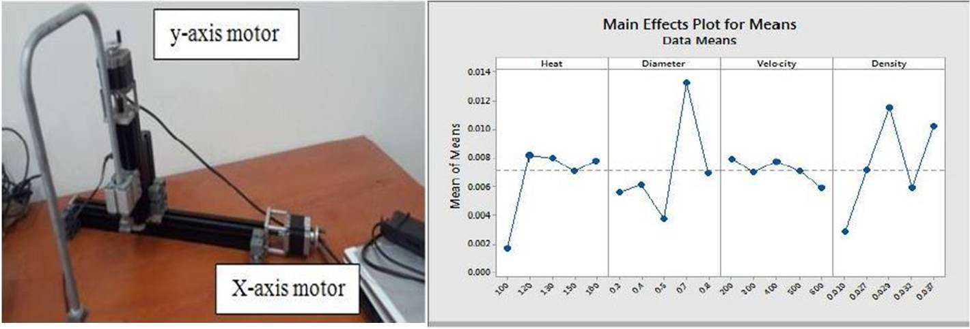

Figure 1.Two Axis of CNC Machine Effects

### **Second Project**

Second project is CNC Foam Cutting Machine. This machine project is suitable for both 2D and 3D cutting. It allows all kinds of cuts with its wide range of uses. For example, cylindrical and thick plate parts. "Power Machine", which is one of the patented companies in our country, is the machine produced.

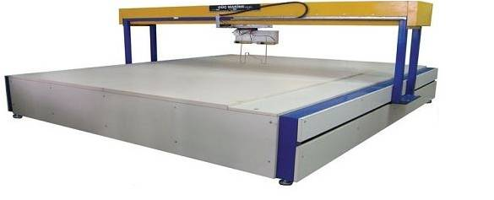

Figure 2 Three Axis of CNC Machine

### **Third Project**

Third project is Four Axis Hot-Wire Foam Cutter Controlled by Mindstorms EV3. The purpose of this project is to create prototypes that will perfect the design with the help of 4-axis numerical control of the designs of flying aircraft. In addition, mixed motifs in 3D models have been the reason for the need. Moreover, the first foam cutting machine made with lego parts in addition.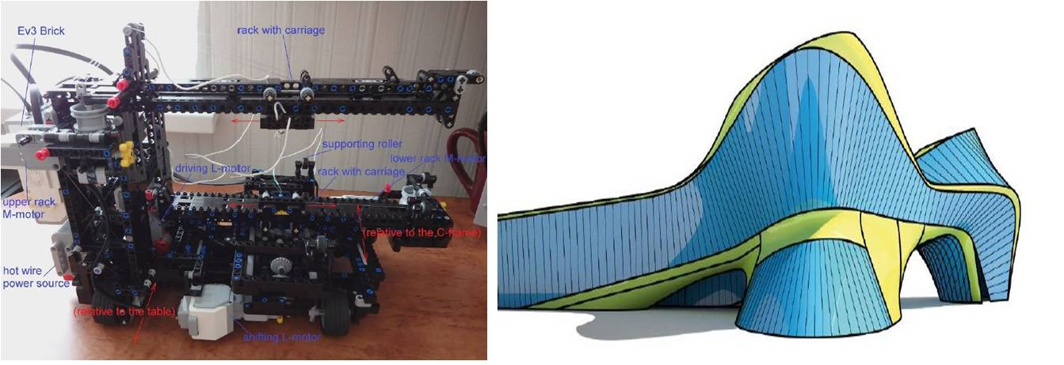

Figure 3a) Four-Axis of CNC Machine 3b) Complex Design

### **Last Project**

Final project is Rough Machining Process and Its Simulation for Robot Integrated Surface Sculpturing System Design. In the CAM section, it corrects errors that may occur during cutting using offset technique. It has 8-axis. These are 2-axis worktables and 6-axis manipulators.

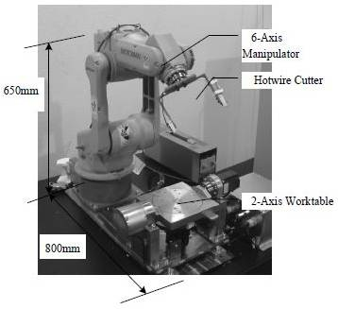

Figure 4.8-Axis CNC Hot Wire Machine

## Design Route Map

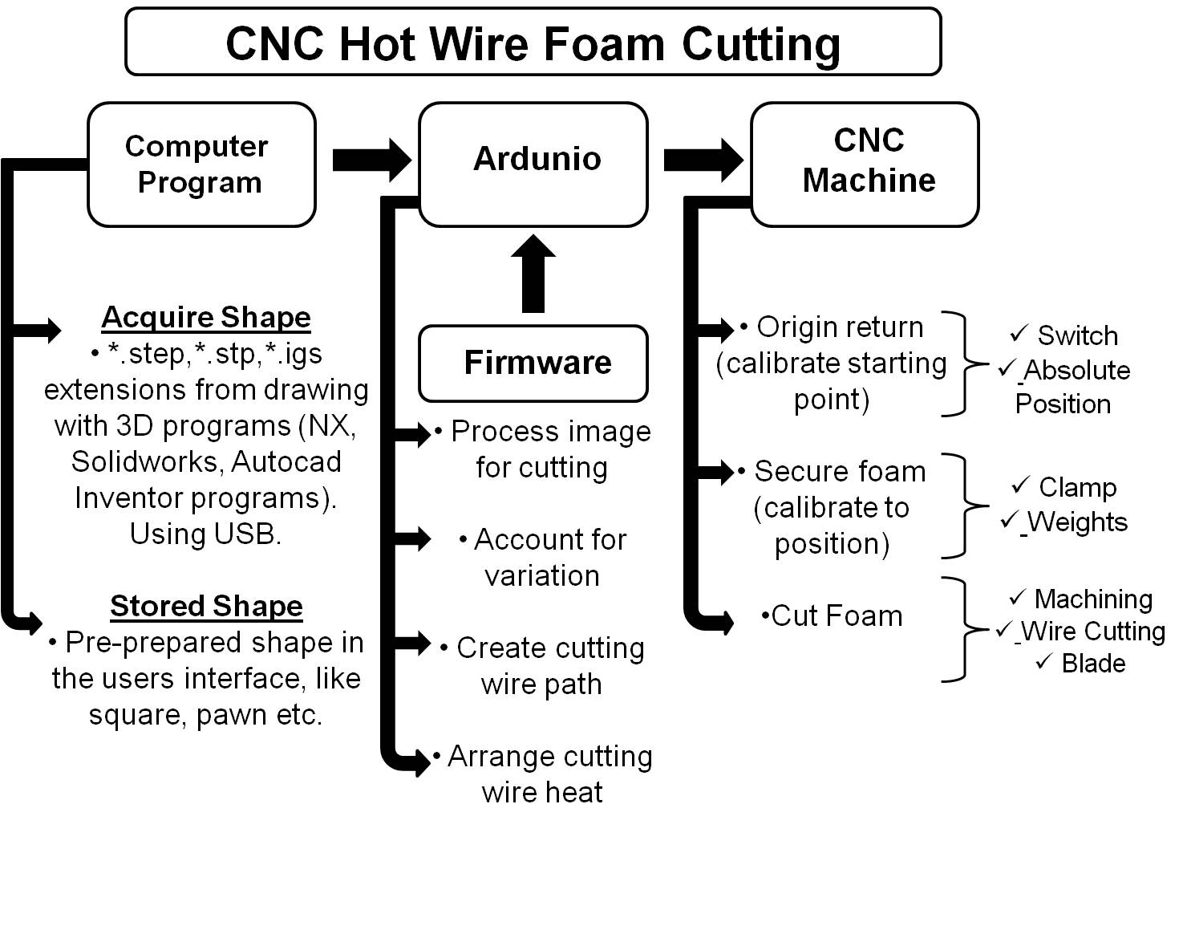

Figure 5 Operation Process Chart

# DETAILED DESIGN

## Sub-System of the Design

* Motion System
* Cutting System
* Structure
* Software

# Motion System

Stepper motors are designed to be used to allow the cutting wire to move up and down or backward. In addition, control of the movement is available to switch on the y and z axis. Step of the screw shaft will be used in the turn of stepper motors. The rotating table at the bottom also helps the foam material rotate with certain steps with stepper motor movement and cut the foam material.

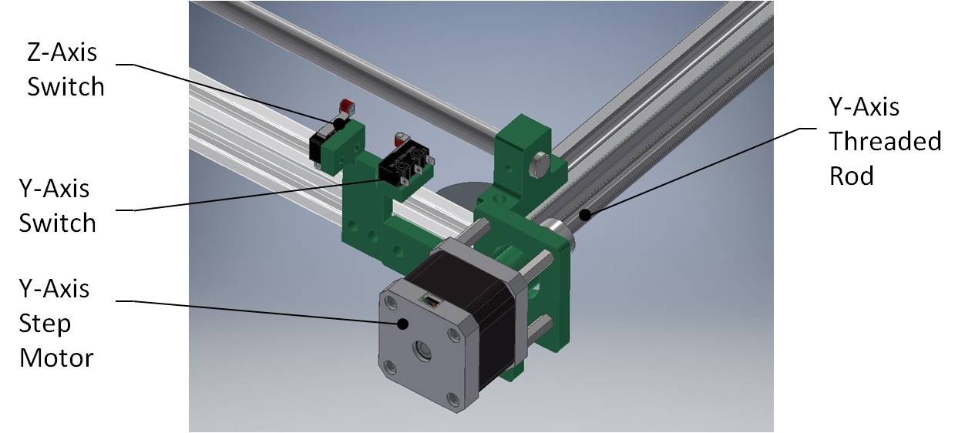

Figure 6: Y-Axis Motion

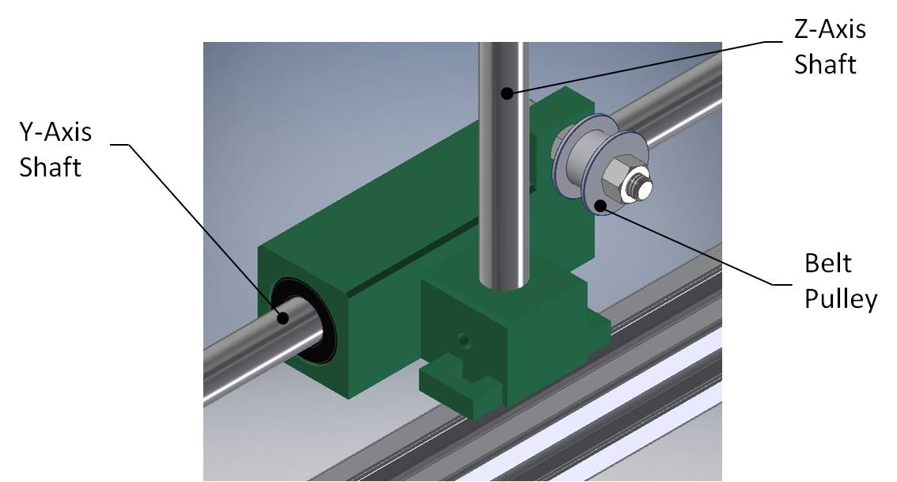

Figure 7: Y and Z-Axis Motion

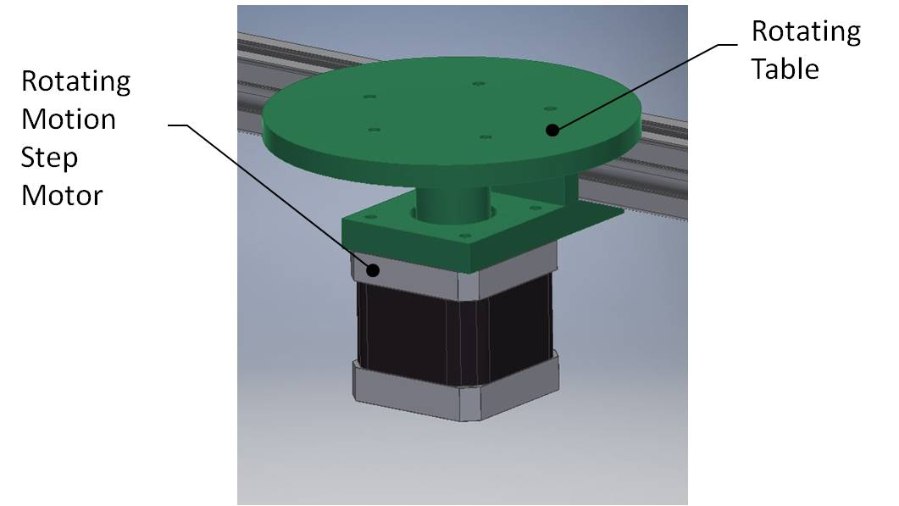

Figure 8: Rotating Motion

# Cutting System

The features of the cutting wire we will use are as follows;

* Chemical Properties (Nichrome) ,
* NiCr (A) –NiCr (80%) and Cr (20%)
* NiCr (C) –NiCr (60%) and Cr (15%) and Fe (25%)
* According to research the temperature is 100°C diameter of wire **d=0.5mm**, velocity of cut is $V=300mm/min$. and density of foam is $ρ=0.032g/{cm}^{3}$**.**
* Generally companies is using $±0.5mm$ for cutting wires. We wanted to be $±0.05mm$**[1]**
* We will use spring for taking the tension of wire

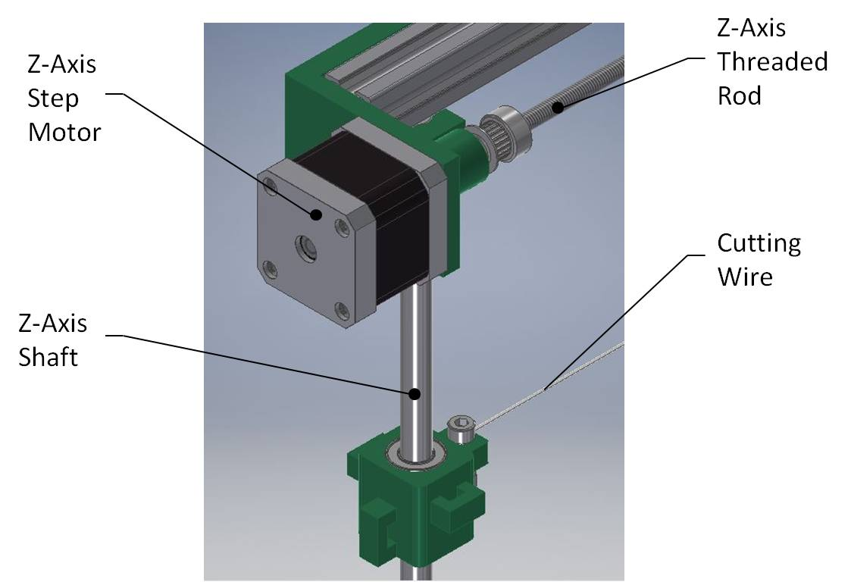

Figure 9: Z-Axis Motion and Cutting Wire

# Structure

We thought to use aluminum sigma profiles with cost, lightness and durability in creating the structure of the design. We will also expose the required fittings and profiles with a 3D printer. In this way, we will be able to intervene ourselves, if there is a change in design. In particular, the step of the screw shaft and the movements of the stepper motor are selected in harmonic motion.

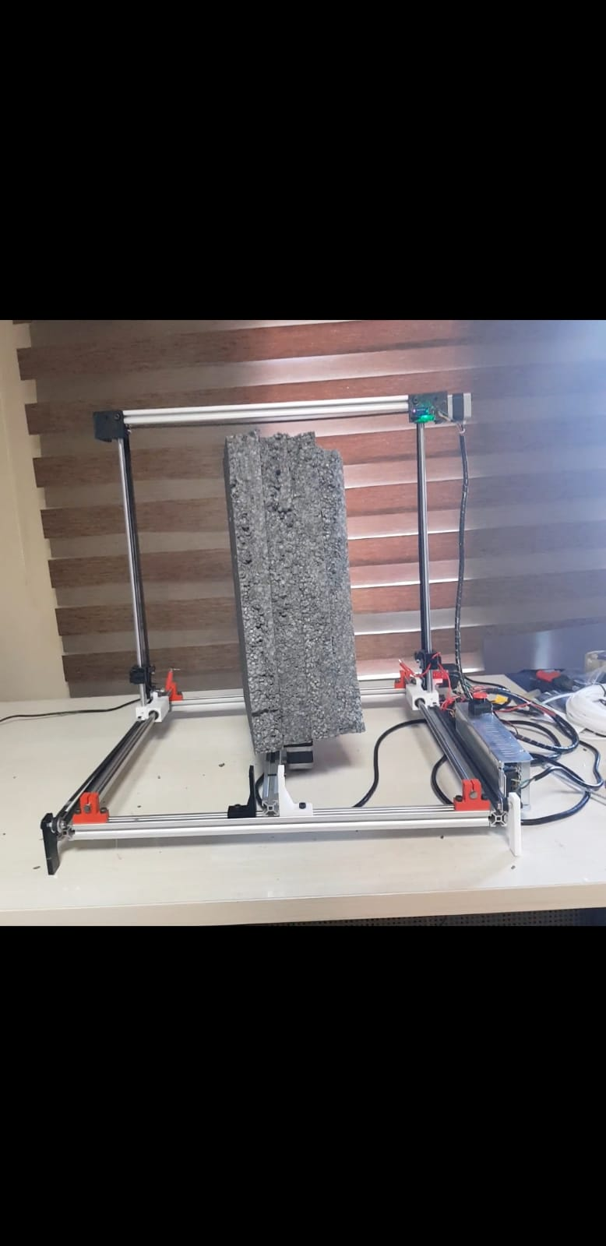

Figure 10

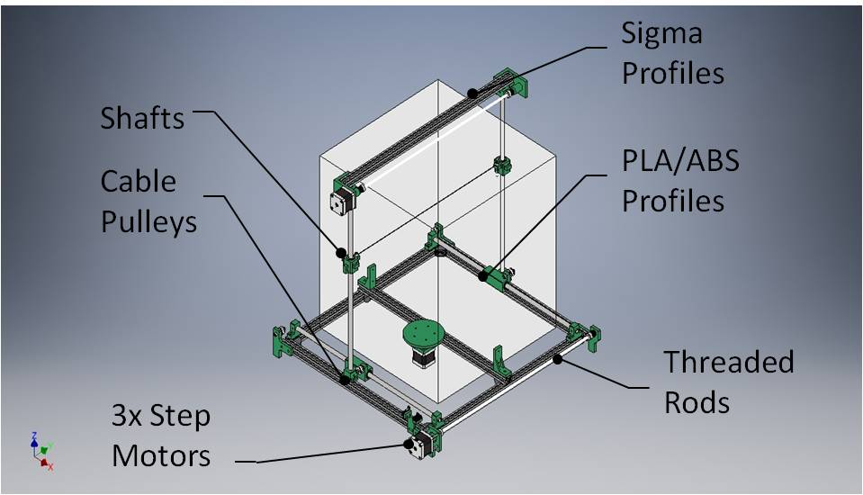

Figure 11: Foam Cutting Structure

* + - 1. **Calculations**
* **TERMAL ANALYSIS:** Assuming a uniform wire temperature, $T_{max}=T(r=0)≡T_{0}≈T_{s}$ the maximum volumetric heat generation may be obtained from equation, but with the total heat transfer coefficient, $h_{t}=h+h_{r}$

Known:

D=1mm

$ρ_{e }=1x{10}^{-6}Ω.m$

$$k=25W/{m.K}$$

$$ε=0.65-0.79$$

$T_{∞}=20℃$ ${(T}_{sur.}=T_{∞})$.

Also, $T_{∞}=\left(273.15+20\right)℃=293.15℃$

$T_{max}=1093℃ {(T}_{max}=T_{s})$.

Also, $T_{max}=\left(273.5+1093\right)℃=1366.15℃$

$$σ=5.67x{10}^{-8}W/{m^{2}K^{4}}$$

$$h=120W/{m^{2}K}$$

$$∆E=220V$$

DC Power Supply Properties: 12V, 5A, 60W

$$I=1.55A$$

$$L≅470mm=0.47m$$

Note: At room temperature, Ni-chrome has an electrical resistivity between $1x{10}^{-6} to 1.5x{10}^{-6} W.m$

$$h_{r}=εσ\left(T_{s}+T_{sur.}\right)\left(T_{s}^{2}+T_{sur}^{2}\right)$$

$$h_{r}=\left(0.72\right)(5.67x{10}^{-8}W/{m^{2}K^{4})}\left(1366.15+293.15℃\right)({1366.15}^{2}+{293.15}^{2})=132.2W/{m^{2}K}$$

$$h_{t}=\left(120+132.2\right) W/{m^{2}K}=252.2W/{m^{2}K}$$

$${\dot{q}}_{max}=\frac{{2h}_{ t}}{r_{0}}\left(T_{s}-T_{∞}\right)=\frac{(2x252.2)W/{m^{2}K}}{0.0005m}\left(1366.15-293.15\right)℃ =1.08x{10}^{9}W/{m^{3}}$$

$$\dot{q}=\frac{I^{2}R_{e}}{∀}=\frac{I^{2}({ρ_{e}L}/{A_{c})}}{{LA}_{c}}=\frac{I^{2}ρ_{e}}{A_{c}^{2}}=\frac{I^{2}ρ_{e}}{{\left({πD^{2}}/4\right)}^{2}}$$

$$Also, ∆E-IR_{e}-I\left({ρ_{e}L}/{A_{c}}\right)$$

$$I_{max}={\left[\frac{{\dot{q}}_{max}}{ρ_{e}}\right]}^{1/2}\left(\frac{{πD}^{2}}{4}\right)={\left[\frac{1.08x{10}^{9}W/{m^{3}}}{1x{10}^{-6}Ω.m }\right]}^{1/2}\left(\frac{{π(0.001m)}^{2}}{4}\right)=25.8A$$

$$L=\frac{∆E.A_{c}}{I_{max}ρ_{e}}=\frac{220V\left[{π(0.001m)}^{2}/4\right]}{25.6A(1x{10}^{-6}Ω.m)}=6.71m$$

$$P_{elec.}=∆E.I_{max}=\left(220V\right)\left(25.8A\right)≅5.70kW$$

Important note: According to our experiment results, we have measured most suitable condition 1.55A for current value, 11.50V, wire temperature 108.5°C.

Figure 12 Temperature versus Distance Graph

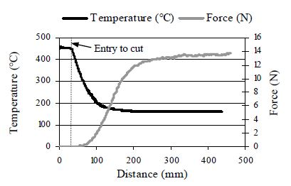

* **Belt and idler pulley**

**Belt properties**

Material: Rubber

Width:6mm

Pitch:2mm

**Pulley Properties**

Material: Aluminum

number of teeth: 20

Width: 16mm

$$Pd=Pitch diameter$$

$$P=Pitch$$

D= Diameter large pulley

d=diameter small pulley

C=Center distance

$$θ=Angle of contact$$

$$θ_{d}=π-2\sin^{-1}\frac{D-d}{2C}$$

$$θ_{d}=π+2\sin^{-1}\frac{D-d}{2C}$$

The length of the belt is that,

$$L={\left[4C^{2}-{\left(D-d\right)}^{2}\right]}^{1/2}+\frac{1}{2}\left(Dθ_{D}+dθ_{d}\right)$$

For this belt, the angle of wrap is the same for the both pulley and is

$$θ=π+2\sin^{-1}\frac{D+d}{2C}$$

The belt length for crossed belts is found to be

$$L={\left[4C^{2}-{\left(D-d\right)}^{2}\right]}^{1/2}+\frac{1}{2}\left(D+d\right)θ$$

$$Pd=P x\frac{ \#of teeth}{π}=2mm x \frac{20}{π}=12.7mm$$

**The belts and pullers located in the horizontal direction;**

D=Ø19mm

d=Ø16.5mm

C=531mm

$$θ_{d}=π-2\sin^{-1}\frac{D-d}{2C}=π-2\sin^{-1}\frac{19mm-16.5mm}{2(531mm)}=2.9°$$

$$θ_{d}=π+2\sin^{-1}\frac{D-d}{2C}=π+2\sin^{-1}\frac{19mm-16.5mm}{2(531mm)}=3.4°$$

$$L={\left[4C^{2}-{\left(D-d\right)}^{2}\right]}^{1/2}+\frac{1}{2}\left(Dθ_{D}+dθ_{d}\right)$$

$$L={\left[4{\left(531mm\right)}^{2}-{\left(19mm-16.5mm\right)}^{2}\right]}^{1/2}+\frac{1}{2}\left(19mmx2.9+16.5mmx3.4\right)$$

$$L=1118.225mm or L=1.118m$$

$$θ=π+2\sin^{-1}\frac{D+d}{2C}=π+2\sin^{-1}\frac{19mm+16.5mm}{2(531mm)}=3.4°$$

**The belts and pullers located in the vertical direction;**

D=Ø19mm

d=Ø16.5mm

C=472mm

$$θ_{d}=π-2\sin^{-1}\frac{D-d}{2C}=π-2\sin^{-1}\frac{19mm-16.5mm}{2(472mm)}=2.8°$$

$$θ_{d}=π+2\sin^{-1}\frac{D-d}{2C}=π+2\sin^{-1}\frac{19mm-16.5mm}{2(472mm)}=3.4°$$

$$L={\left[4C^{2}-{\left(D-d\right)}^{2}\right]}^{1/2}+\frac{1}{2}\left(Dθ_{D}+dθ_{d}\right)$$

$$L={\left[4{\left(472mm\right)}^{2}-{\left(19mm-16.5mm\right)}^{2}\right]}^{1/2}+\frac{1}{2}\left(19mmx2.9+16.5mmx3.4\right)$$

$$L≅944mm or L=0.944m$$

$$θ=π+2\sin^{-1}\frac{D+d}{2C}=π+2\sin^{-1}\frac{19mm+16.5mm}{2(531mm)}=3.4°$$

* **Shaft Calculation**

$$l=500mm$$

$$D=∅10mm$$

$γ=78-80 kN/m^{3}$ $γ=Specific Weight(SI System)$

Material: Stainless Steel

$$E_{Steel}≅207GPa (30Psi)$$

$$I=\frac{π}{4}r^{4}=4.90x{10}^{-10}m^{4}$$

$EI=\left(207GPa\right)x(\frac{{10}^{6}kN/m^{2}}{1GPa})x(4.90x{10}^{-10}m^{4})$

$EI=0.1014kN/m^{2} or$ $EI=101.4kN/m^{2}$

$$ω_{1}={\left(\frac{π}{l}\right)}^{2}\sqrt{\frac{EI}{m}}={\left(\frac{π}{0.5m}\right)}^{2}\sqrt{\frac{0.1014kN/m^{2}}{0.314kg}}=0.57rad/s$$

* **Ball Bearing Calculation**

$$F=28N$$

$$n_{D}=227rpm$$

$$L_{D}=22700$$

$$p=3,$$

$$C=0.618x{10}^{3}N$$

$$P=0.01x{10}^{3}N$$

$$L_{10}={\left(\frac{C}{P}\right)}^{p}={\left(\frac{0.618x{10}^{3}N}{0.01x{10}^{3}N}\right)}^{3}=236,029$$

Safety transportation rating $\frac{C}{P}=61.8$

$$x_{D}=\frac{L_{D}}{L_{R}}=\frac{60L_{D}n_{D}}{L_{10}}=\frac{60\left(22700\right)(227)}{236029}=155.8≅156$$

Thus design life 156 times the $L_{10}$ life for a ball bearing a=3. Then from the table

Application factor: 1.2, reliability = 0.99, and weibull parameter: 0.02,

$$\left(θ-x_{0}\right)=4.439,$$

$$b=1.483.$$

$$C_{10}=\left(1.2\right)\left(28N\right){\left[\frac{156}{0.02+4.439{\left(1-0.99\right)}^{1/{1.483}}}\right]}^{1/3}=299.04N$$

* **Linear Bearing Calculation**

$$L=29mm$$

$$D_{outer}=∅19mm$$

$$D_{inner}=∅10mm$$

$$L_{10}={\left(\frac{f_{H}{.f}_{t}{.f}_{B.}C}{f_{s}.k.p}\right)}^{3}$$

|  |  |  |  |  |  |  |  |
| --- | --- | --- | --- | --- | --- | --- | --- |
| Bearing Type | $$L\left(mm\right)$$ | $$D_{Inner}$$ | $$D_{outer}$$ | $$C_{max.(N)}$$ | $${Co}_{max.}(N)$$ | $$C_{min.}(N)$$ | $$W\left(gr\right)$$ |
| KB10 | 29 | 10 | 19 | 540 | 420 | 455 | 31.56 |
| KB12 | 32 | 12 | 22 | 640 | 570 | 540 | 36.54 |
| KB16 | 36 | 16 | 26 | 840 | 780 | 710 | 36.5 |

Table 6 Linear bearing measurements

Also, $the values are taken from the table (f_{H}, f_{t}, f_{B}, f_{s} and k)$

$$P=\frac{W}{2}=\frac{0.314kg}{2}=0.157kg (Radial Loading)$$

$$L_{10}={\left(\frac{\left(1.0\right)\left(1.0\right)\left(1.414\right)(455N)}{\left(1.0\right)\left(1.0\right)(0.157kg)}\right)}^{3}$$

$$L_{10}=344x{10}^{10}$$

* **Worm Screw**

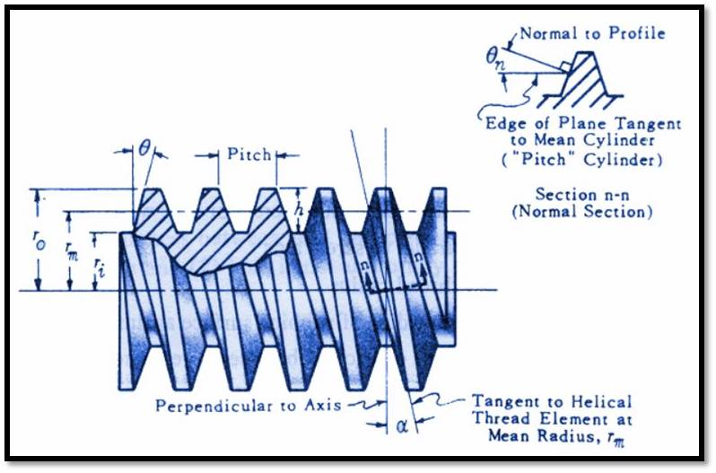

Figure 13 Worm screw measurements

Applied torque, $T=28000Nmm$

Major thread radius (Major diameter/2), $r_{0}=3mm$

Thread depth, $h=0.5mm$

Minor thread radius, $r_{i}=r_{0}-h$, $r_{i}=2.5mm$

Mean thread radius(pitch diameter) , $$r_{m}=\frac{r_{0}+r_{i}}{2}=2.75mm$$

Effective radial area contact surface, $$r_{c}=r_{m}=2.75mm$$

Coefficient of friction screw thread and mating thread,

$$f=0.01$$

Coefficient of friction at collar,

$$f_{c}=0.01$$

Thread pitch (equals thread pitch for single thread screws), $p=2mm$

Angle of thread of mean radius,

$$α=\tan^{-1}\left(\frac{p}{2πr_{m}}\right)=\tan^{-1}\left(6.60°\right)=0.115rad/s$$

Thread angle at bearing surface (thread included angle),

$$θ=\tan\left(θ\right)\cos\left(α\right)=0.262rad/s$$

Angle between tangent to tooth profile, $θ_{n}=0.27$

Thread constant,

$$R_{c}=\left(\frac{\tan\left(α\right)+f/{cos⁡(θ_{n})}}{1-{ftan(α)}/{cos⁡(θ_{n})}}\right)r_{m}+f_{c}r_{c}=0.374mm$$

Load parallel to screw thread axis ,

$N=T/{R_{c}}$, W=74720.4

Efficiency of screw thread mechanism (ratio of work out to work in)

$$E_{screw}=\frac{Wp}{2πT}, E_{screw}=84.94\%$$

* **Acceleration and Deacceleration**

Wire driving $2xπrx\frac{1}{100cm}x1rpmx\frac{1nin}{60s}=5.23x{10}^{-5}m/s$

Worm screw driving $2xπrx\frac{1}{100cm}x1rpmx\frac{1nin}{60s}=3.14x{10}^{-3}m/s$

Specific Speed, $n=\frac{2π(1000)}{60}=104.7rad/s$

Progress per cycle,

* + - 1. **Sketch Drawing**

As shown in the following way, we first decided what kind of operating system the machine will be.

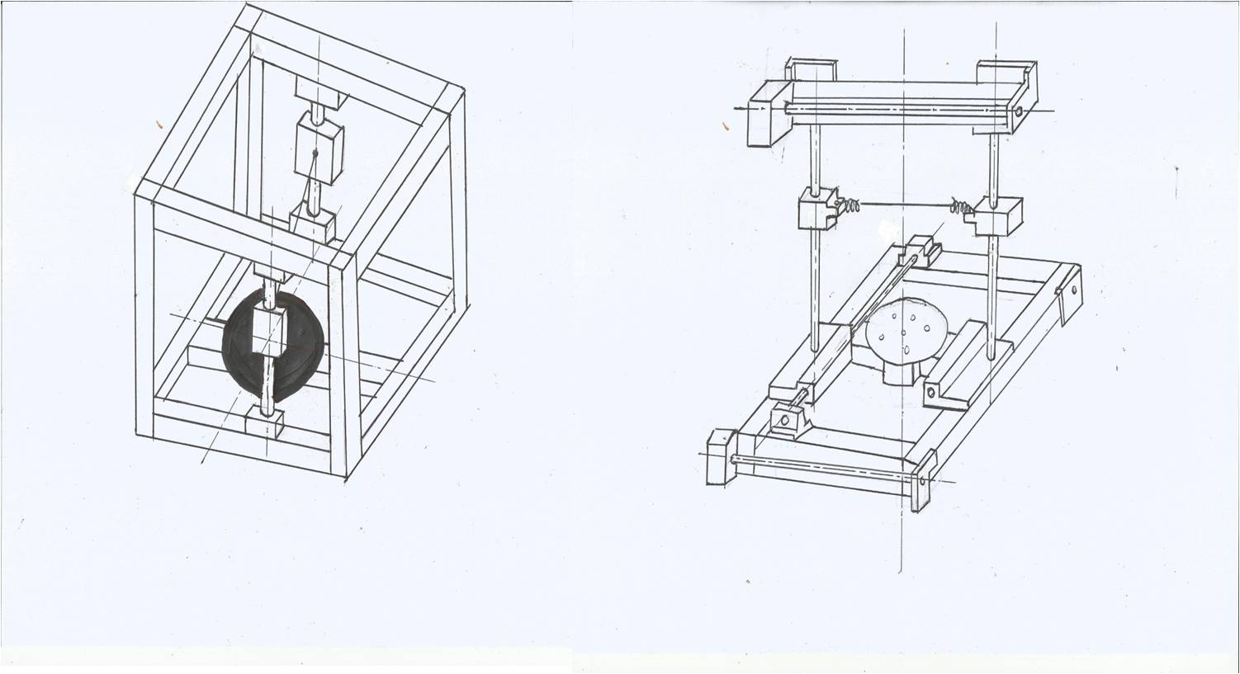

Figure 14 Hand Drawings

* + - 1. **Difficult in Assembly**

While we are assembling, some of parts have broken. This occurred in the locations when the shaft works. These parts have been overhauled and we have changed connection type. You can review it in the figures below.

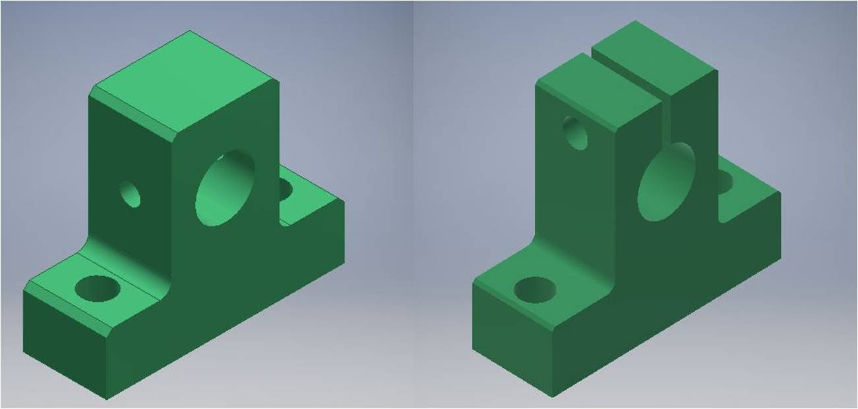

Figure 15a) Old version b) New version

# Software

# WHY ARDUINO UNO?

Arduino Uno is the most basic board available for a beginner, and potentially the best option. It is a good all purpose board with enough features to get a beginner started. Some of its advantageous features are: Its greatest advantage is that we connect the board to the computer via a USB cable which serves a dual purpose of power supply and acts as a Serial port to interface the Arduino and the computer. It can also be powered to DC through a 9V-12V AC adapter. When harmed, which is not possible for other models, the ATmega328 chip can be bought, removed and replaced new. The board works both at 5V, i.e. digital pin output or 5v read, and 0-5V read analog pins. Lots of example code and projects are done with the help of Arduino Uno, so they get good support. The Uno is composed of 14 Digital I / O pins and 6 Analog I / O pins. Created lots of extra hardware add-on for Uno. There's special hardware for internet, bluetooth, motor control etc. Also, it is price performance product.

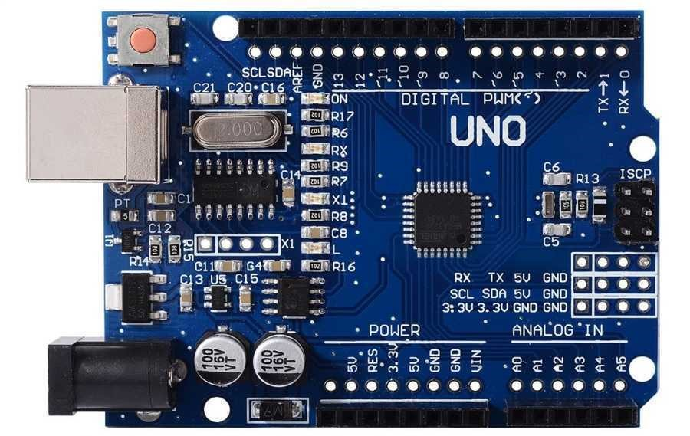

Figure 16 Ardunio UNO

# GRBL Ardunio Library

GRBL is a firmware which controls stepper motors and spindles, lasers, for Arduino panels (uno, nano etc.). GRBL uses g-code as input and sends out signals using Arduino pins. The parallel port controller is used by most industrial CNC devices, which includes these broad purple connectors. GRBL simply plugs the Arduino boards into a free USB port. We'll upload a firmware that controls motion to the Arduino. Most popular choice for CNC machines is GRBL firmware.

# Universal G-Code Sender

Through this program we will do our calibration process. Also, our management screen will be in this program.

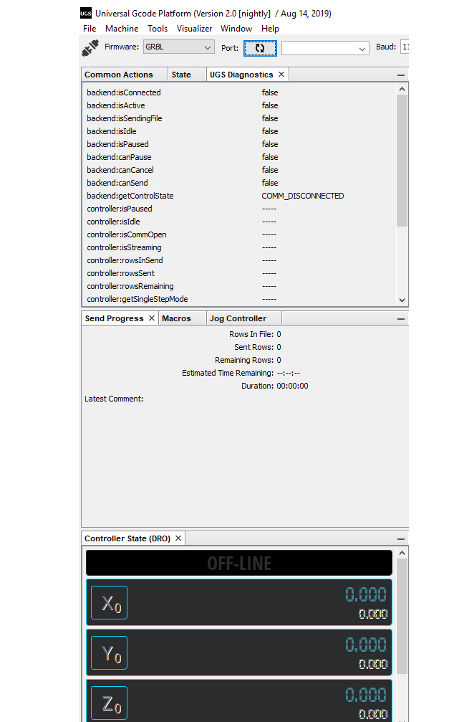

Figure 17: Universal G-Code Sender

## The Implementation of the Project Software

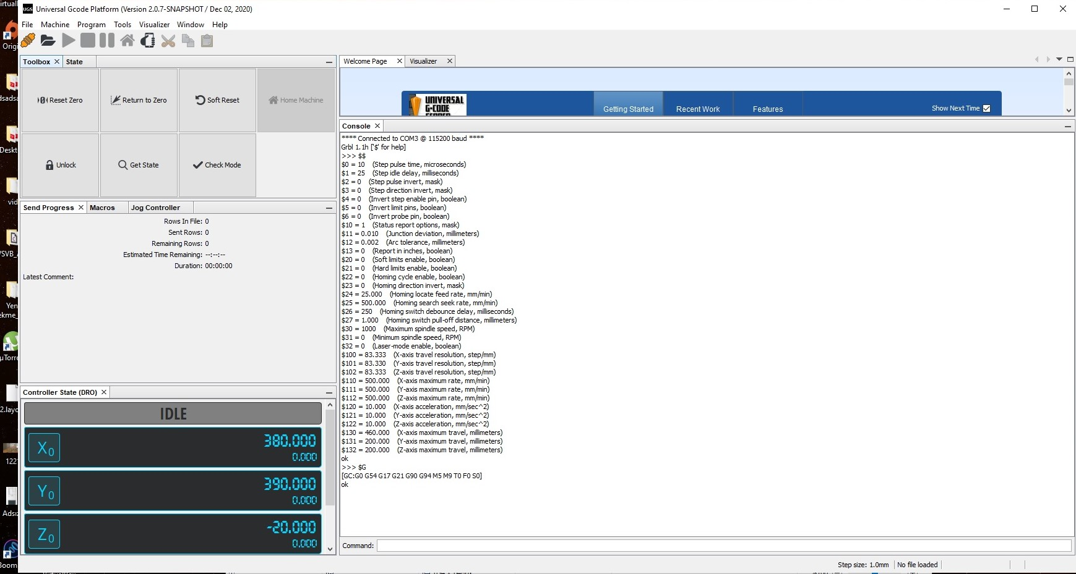

Figure 18

This is the screen that we face when we run the program. We start by selecting the file we want to run from the top of the left.

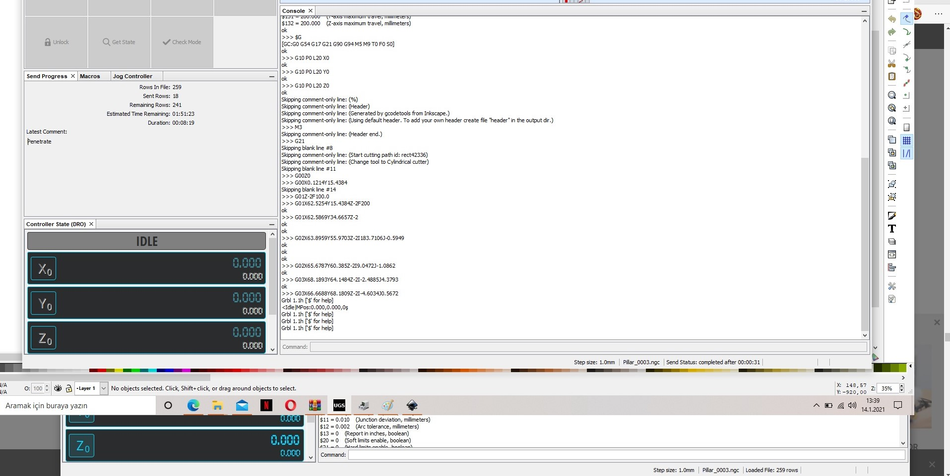

Figure 19

An example of the screen that occurs when we try some works.

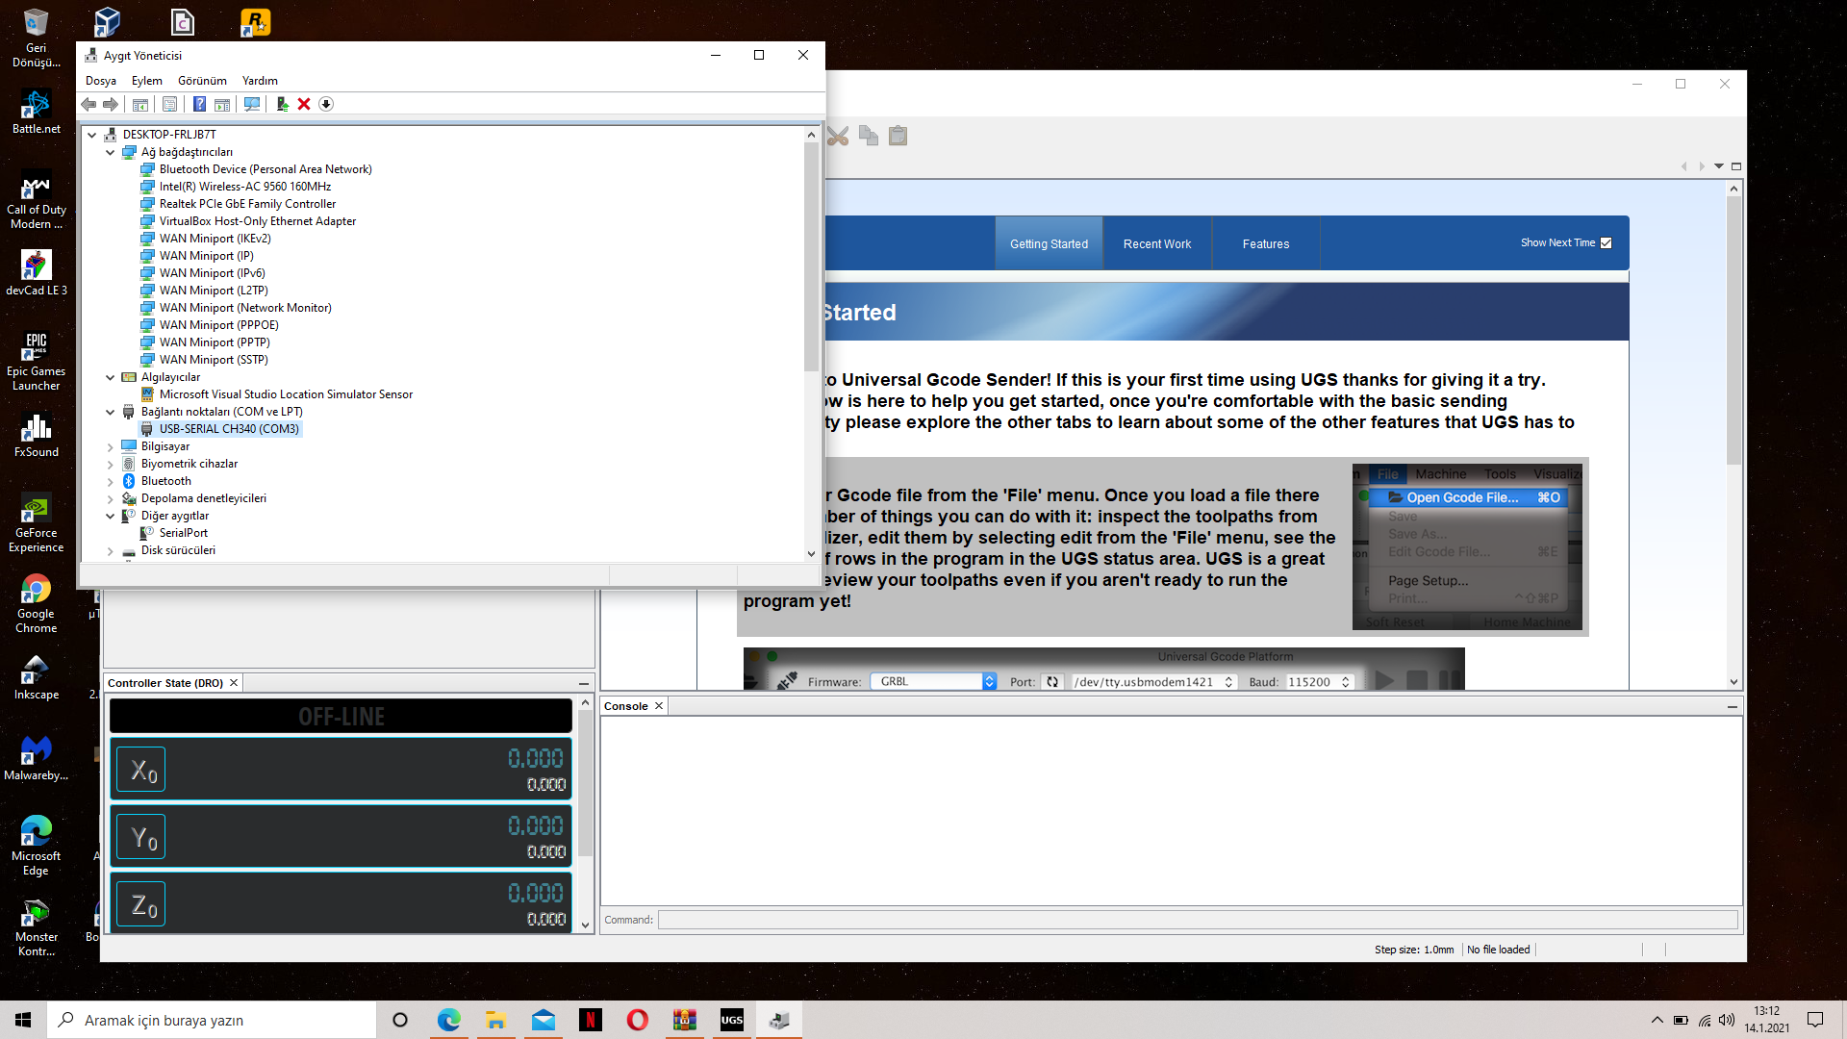

Figure 20

When the program is opened some changes occur in connection port. When we encountered this problem, we wrote the port ourselves from the device manager.

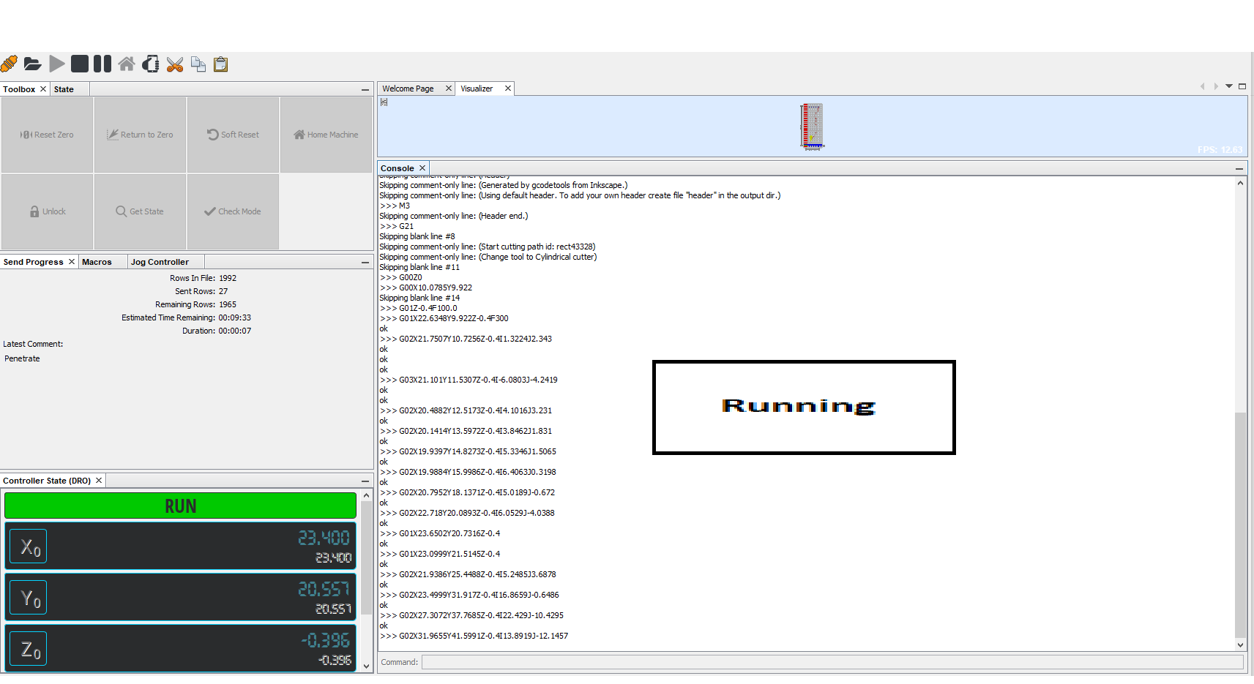

Figure 21

When we start the program It works until the program ends or gives an emergency alarm.

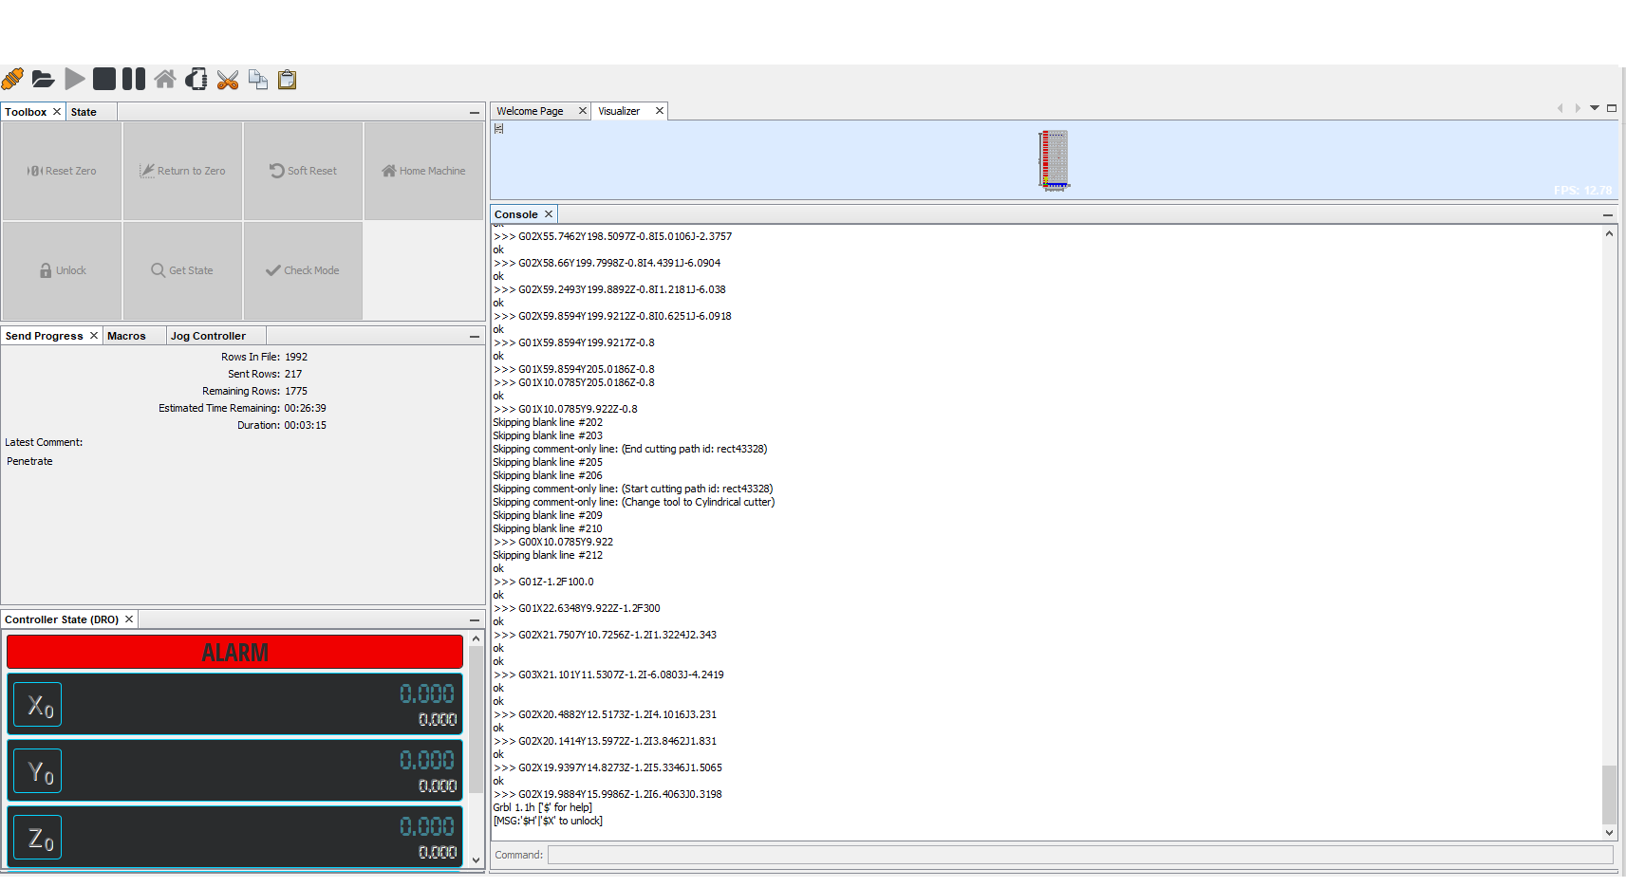

Figure 22

It gives an emergency warning here. Because the user entered the action area or pressed to the emergency button. After that We need to run the program again and reactivate it with the $x command.

## Analysis of the Design

We observed the stress analysis of the wire, which will be most damaged in this section and will need to be replaced over time.

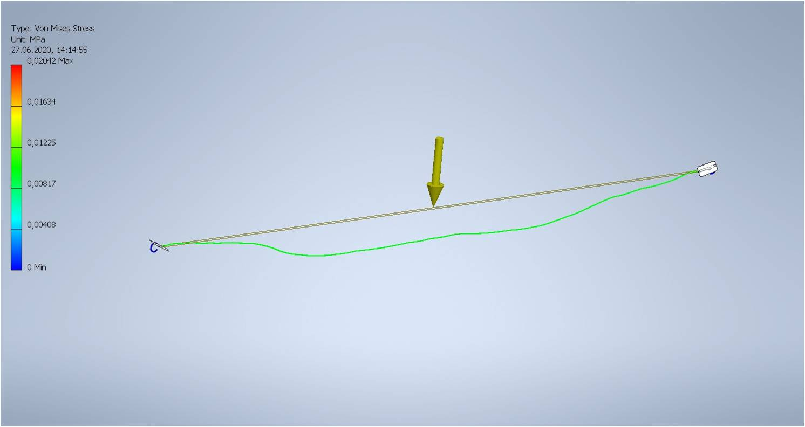

Figure 23: Hot Wire Stress Analysis

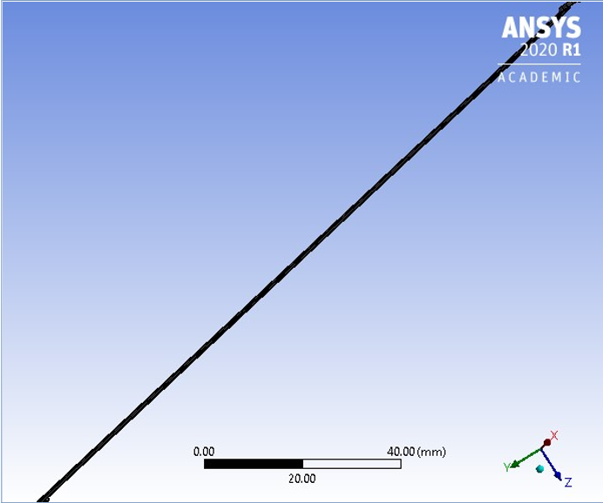

Figure 24

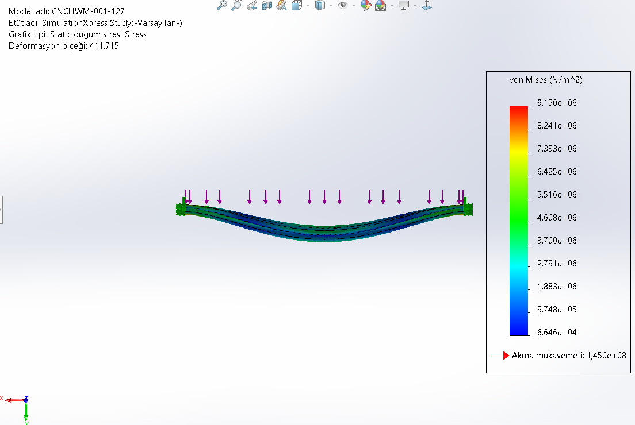

Figure 25

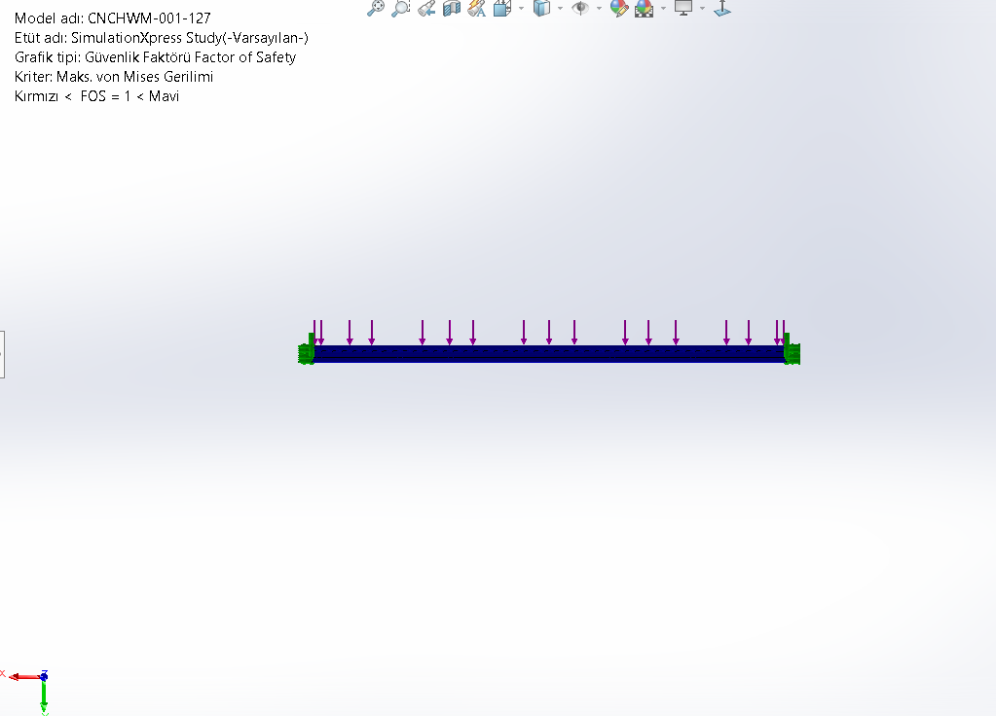

Figure 26

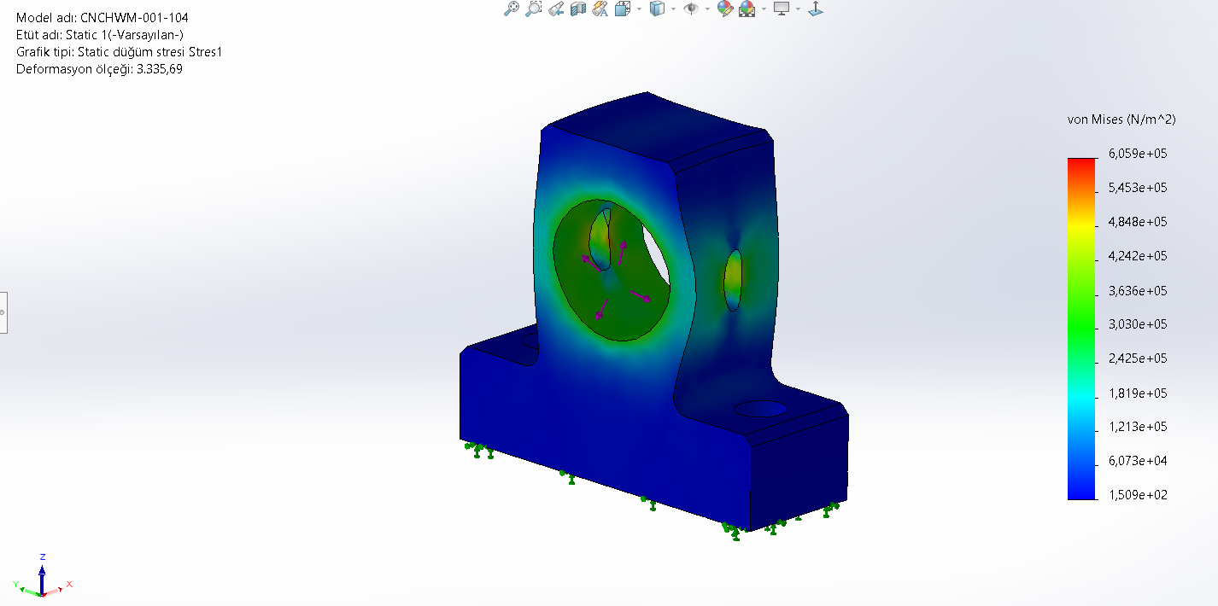

Figure 27

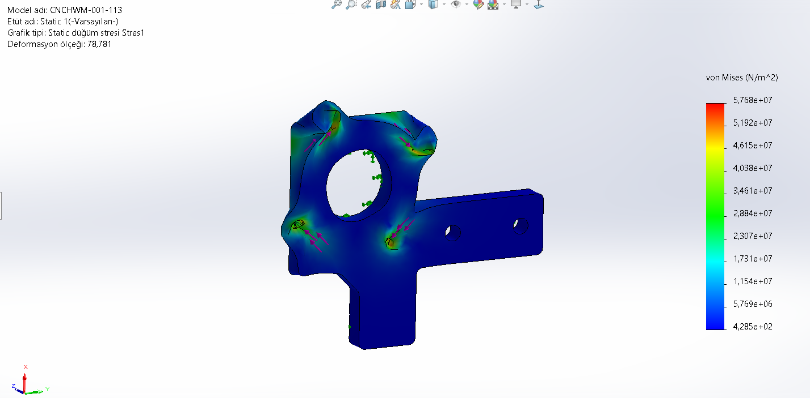

Figure 28

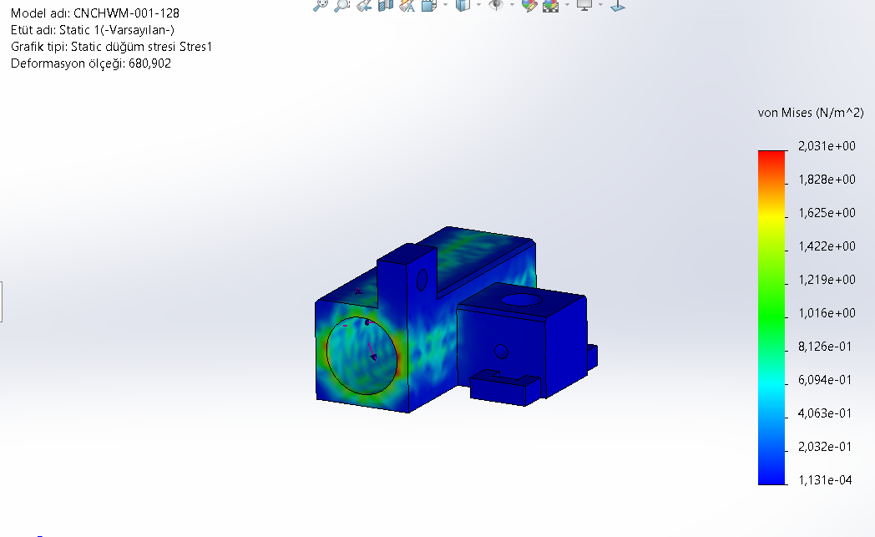

Figure 29

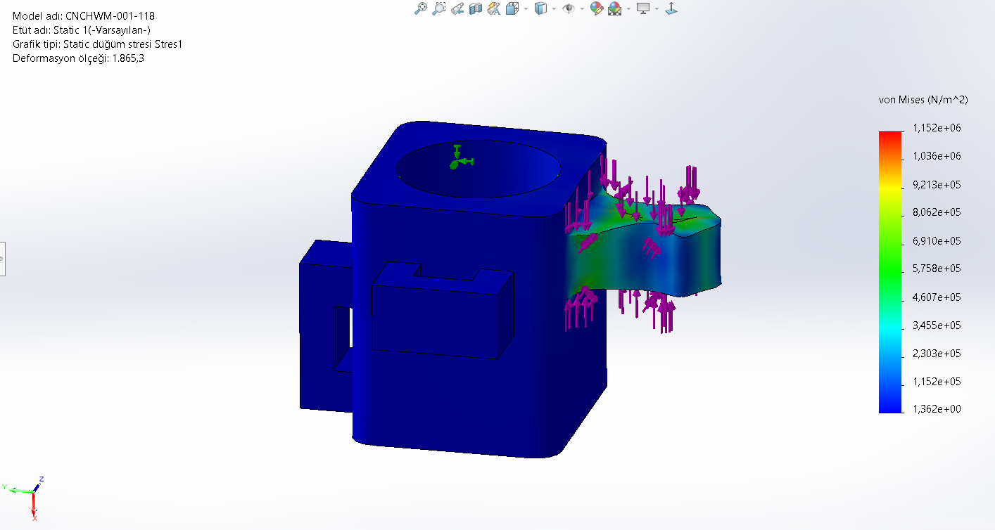

Figure 30

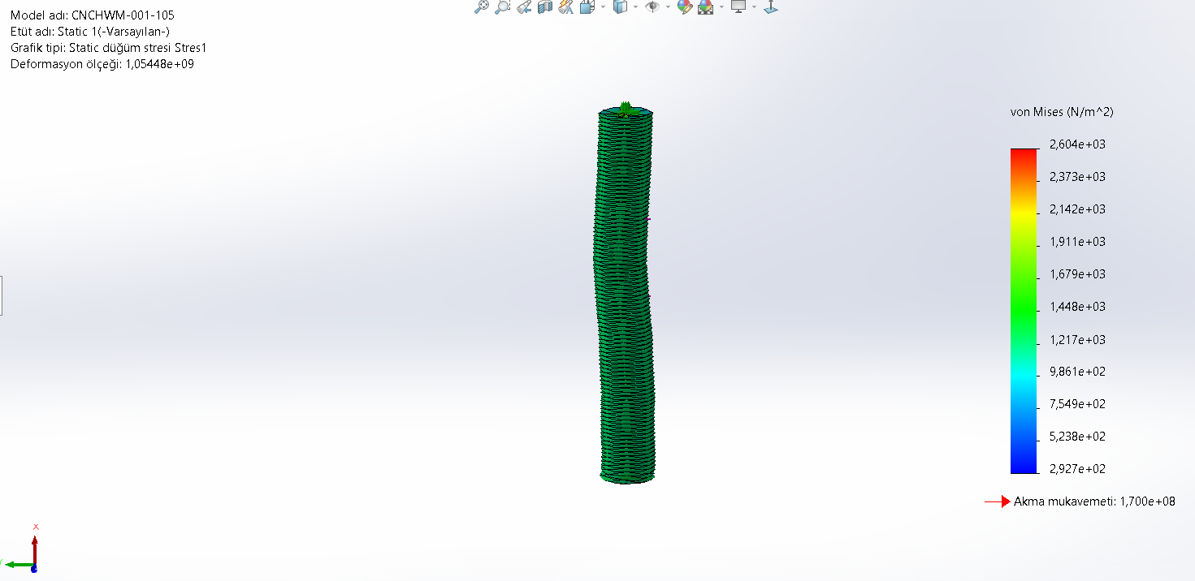

Figure 31

## Virtual Model of the Design

The design in which we create motion, cutting shape, and structure is as follows. You can examine the detailed work in the assembly image we have done.

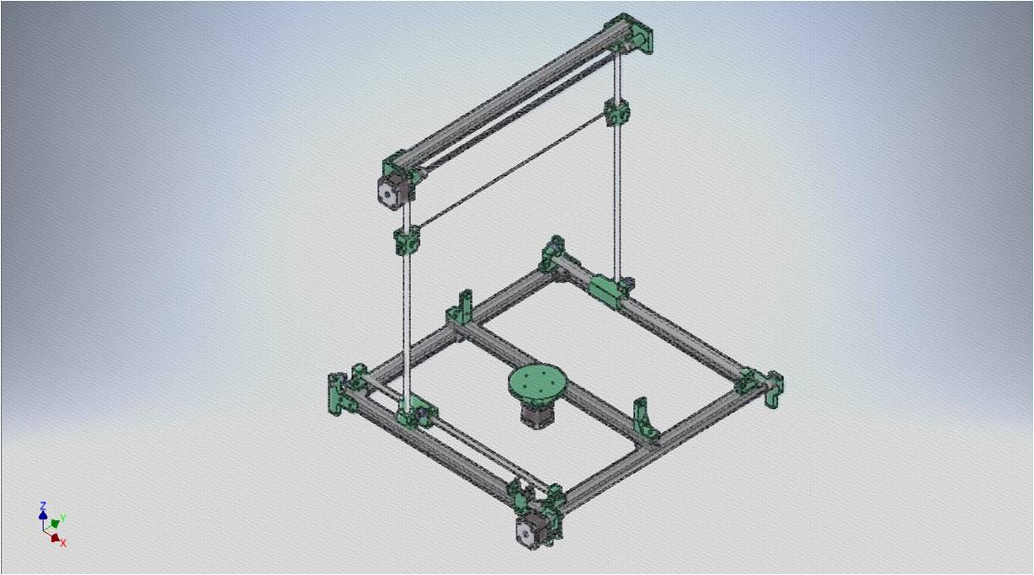

Figure 32 Foam Machine Virtual Model

## Step/mm Settings

When we install the code Grbl, step / mm setting is a random value. For example while our value was 300, when we said go 10 mm, it went 30. We find a solution by saying what should we do to make it go 10. We need to use the $ 100 $ 101 and $ 102 commands. As a result of the values in our program, $ 101 = 250/3 gave us the appropriate setting.

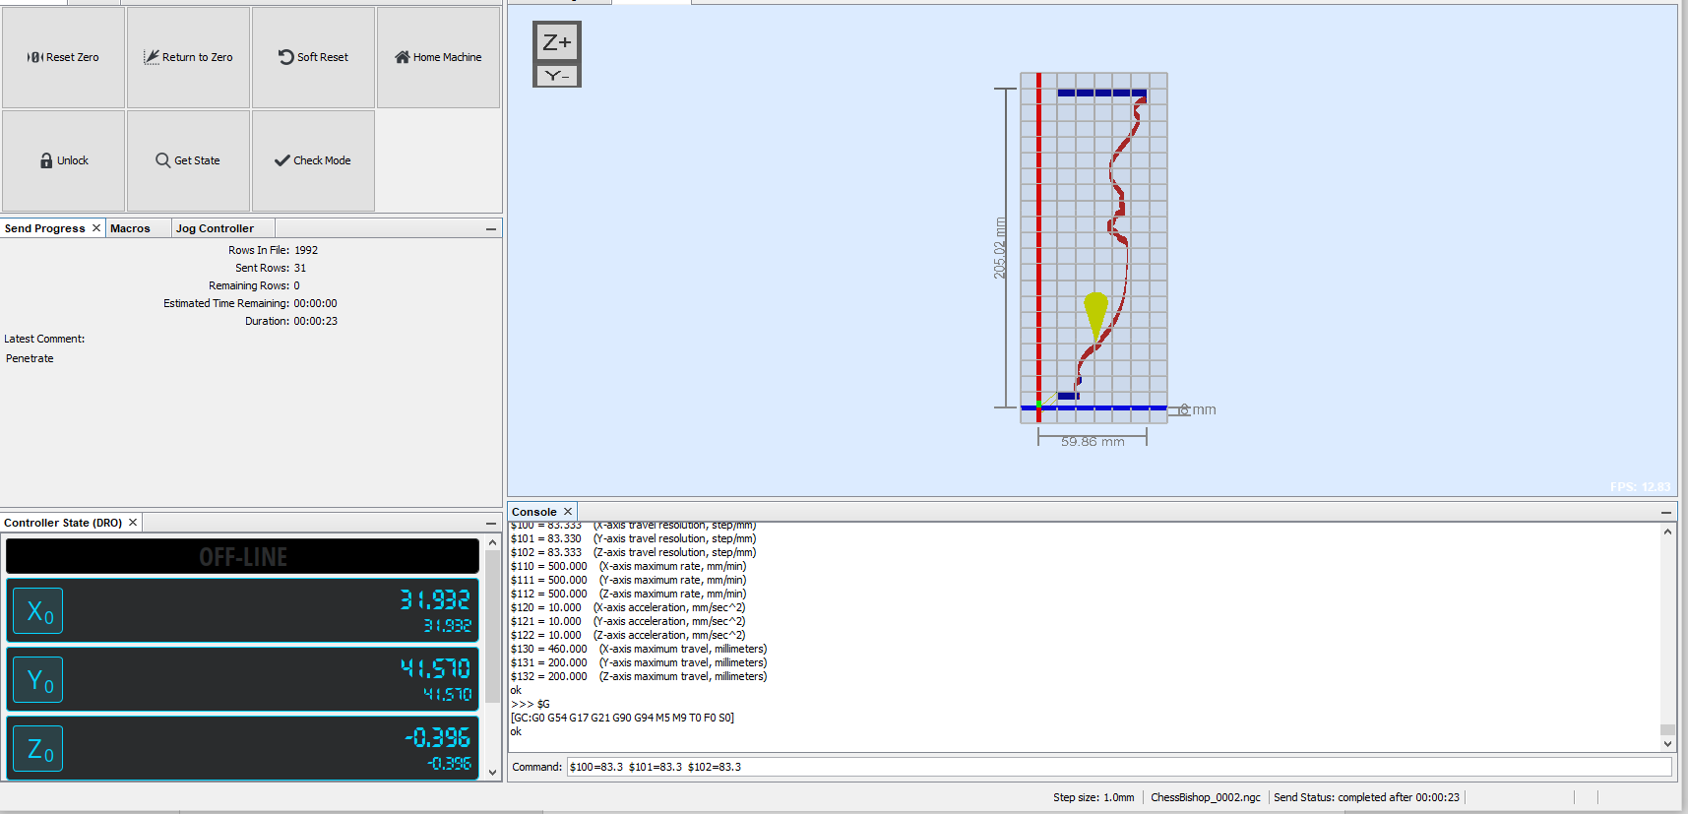

Figure 33

# CONCLUSION and DISCUSSION

First in our Project we investigated the machines used in the world and in our country and then we listed the work that our machine will do with our teachers in the project course. We searched for material to match the performance of our machine. Some of these are DC power supply, step motor, step drive, Arduino cards and some software programs. After the meeting with our teachers, we created a list of materials to use. As the final stage, we created a design in the drawing program environment. We have put our machine up and running this period and completed our project.

## REFERANCESES

[1] <https://www.mendeley.com/catalogue/d43c1da3-714d-33a6-85a0-20fb66e41b19/>

[1] <https://www.mendeley.com/catalogue/2e2f114b-0cf0-36a9-a3d4-321727e254f0/>

[2] <https://www.mendeley.com/catalogue/54764477-acad-3b9a-803a-4e0b023df04b/>

[3]<https://www.researchgate.net/profile/Jiang_Zhu19/publication/266882022_Rough_Machining_Process_and_Its_Simulation_for_Robot_Integrated_Surface_Sculpturing_System/links/5554c2a808aeaaff3bf45334.pdf>

[4] <https://portal.turkpatent.gov.tr/anonim/arastirma/patent/detayli>

[5] <https://www.mendeley.com/catalogue/952959fd-172d-38d8-a464-d664fa5372ea/>

<https://ir.canterbury.ac.nz/handle/10092/5622>

[6] <https://patents.google.com/patent/US20110314984A1/en>

[7] <https://block.arch.ethz.ch/brg/files/IABSE-IASS2011_Rippmann-Block.pdf>

<https://www.mendeley.com/catalogue/1dedc223-5d49-3f1b-9af5-b4b6dcf11233/>

[8] <https://www.sciencedirect.com/science/article/pii/S0890695516300475>

<https://www.mendeley.com/catalogue/76fe0c52-1c84-3e52-8125-44186af5eac7/>

[9] <https://www.mendeley.com/catalogue/7dd98aa6-1ade-3129-985c-084945b378de/>

[10] <https://link.springer.com/chapter/10.1007/978-3-319-61276-8_62>

[11] <https://www.mendeley.com/catalogue/c1f6a1ba-25b7-3a96-8721-a515bc5cc8aa/#abstract-title>

[12] https://www.mendeley.com/catalogue/c531b3bf-43b6-3a64-9471-358b9fc7a4c8/

[13] <https://medias.schaeffler.de/de/criteria-for-bearing-selection#belastung>

[14] <http://saygilirulman.com.tr/rulman-omur-hesabi>

[15] <https://www.engineeringchoice.com/belt-drive-types-material-types-of-belt-advantages-disadvantages/>

[16] <https://www.sandvik.coromant.com/tr-tr/knowledge/machining-formulas-definitions/pages/milling.aspx?Country=tr>

[17] <https://www.ozak-linear.com/pdfe/tec/bk_e.pdf>

[18] <https://medias.schaeffler.de/search/searchpage?text=KB>

[19] <https://bilinti.com/arduino-projeleri/arduino-ile-nema-17-step-motor-kontrolu/.html/>

[20] <https://ocw.tudelft.nl/wp-content/uploads/Materiaalkunde_1_slides_chapter5.pdf>

[21] <https://www.engineeringtoolbox.com/density-specific-weight-gravity-d_290.html>

[22] <https://www.engineersedge.com/gears/screw-axial-thrust-load-calculation.html>

[23] http://www.sigmateknik.com.tr/E-Catalogue/

## LITERATURE SURVEY

**Key word:** CNC, foam cutter, hot wire foam cutting machines.

1. At 2003, D. Aitchison, R. Sulaiman was found a machine for a hot wire cutting. Before while the machine is cutting 2½ shapes, they were needed 3D shapes. Also, it has been arranged the optimum heat, and feedback control [1].
2. At 2005, S.D. Y. Yang, H.C. Kim, S.H. Lee, S. K. Park was created a machine for a large size shapes which has 4 axis, and it is cutting asymmetric shapes [2].
3. At 2006 Jiang Zhu, Tomohisa Tanaka, Yoshio Saito were fabricated a robotic machine which has 8 axis. If it is separating, it consist of 6 axis robot and 2 axis worktable, and it works according to CNC operation [3].
4. At 2008 Guc Makina (Turkey) was invented a utility model machine by a hot wire cutting tools and CNC control mechanism [4].
5. At 2009 D. Aitchison, H. Brooks, J. Bain was invented a machine which has a 3D axis. Optimum operating conditions are founded on the machine, like kerf width, applying force, and other parameters [5].
6. At 2010 Simens (United States) was founded a patent machine by a hot wire cutting tools and depending offset principle [6].
7. At 2011, D. Pigram, W. McGee was found a robotic machine which has 7- axis. It has a two dimensional which has works reciprocal between each other [7].
8. At 2016, K. Petkov and J. Hattel was invented a one dimensional machine within Ni-Cr20% wire used in hot wire cutting operation. Also, it has relationship between kerf width, and side angle [8].
9. At 2016, A. Abeysinghe, S. Abeysir have found out a 3D and numerically system machine. Especially the cutting parameters are considered on the machine 9].
10. At 2017, Figliolini, P. Rea, C. Cocomello have designed a 4-DOFs hot wire machine for a experimental works. It has four step motors and it is controlling by CAD-CAM systems. Moreover it has working planer surfaces and skew surfaces [10].
11. At 2018, G. Figliolini, P. Rea, C. Cocomello a 4-DOFs hot wire CNC cutter machine, actually it has 3-DOFs cartesian coordinate and holding apparatus like a fork for hot wire while it is cutting [11].
12. At 2018, H. Hua, T. Jia were came with up a CNC hot wire cutter robotic machine which has a 5-axis [12].

## APPENDICES

## APPENDIX A: Patent Figures

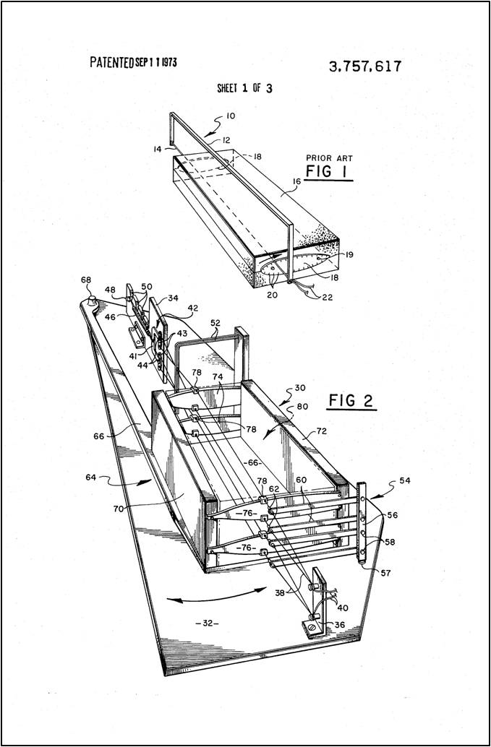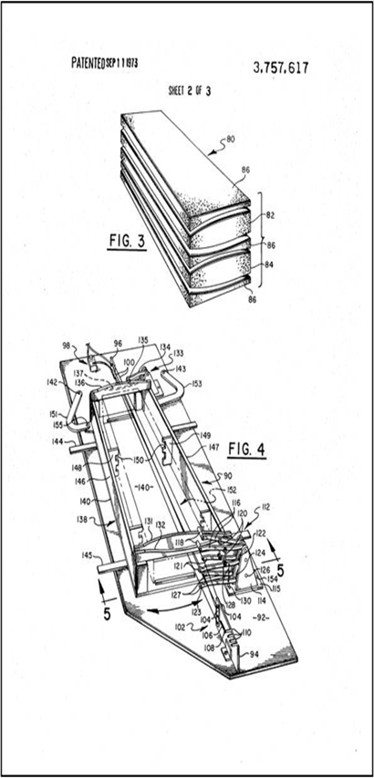

Figure 34 US3757617A'Foam Cutting Apparatus'[A]

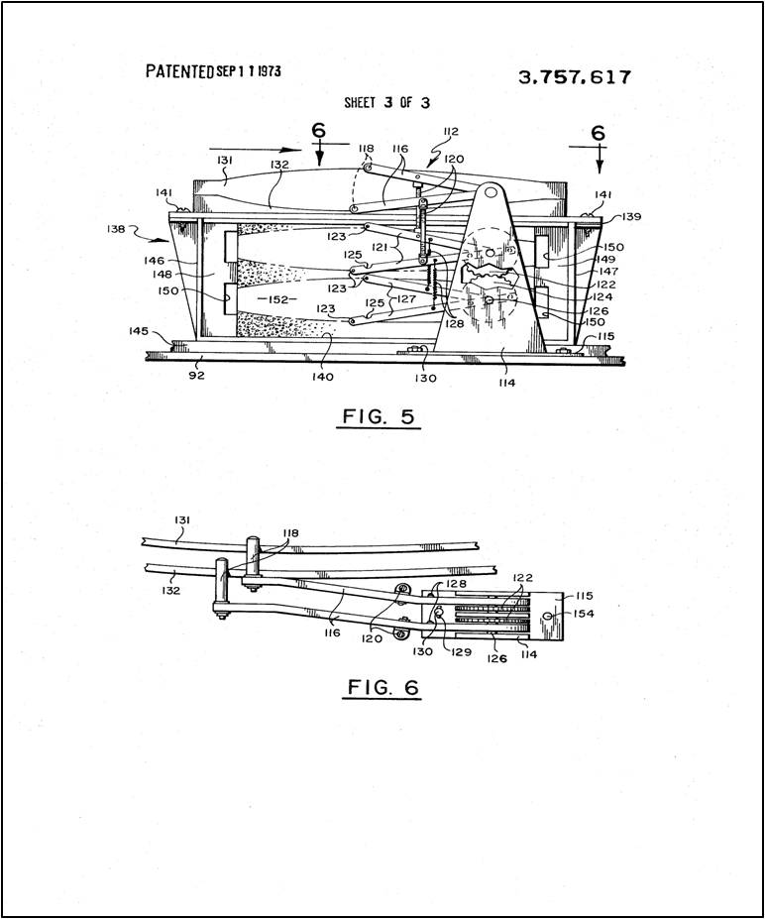

Figure 35 US4601224A'Hot Wire Cutting System'[B]

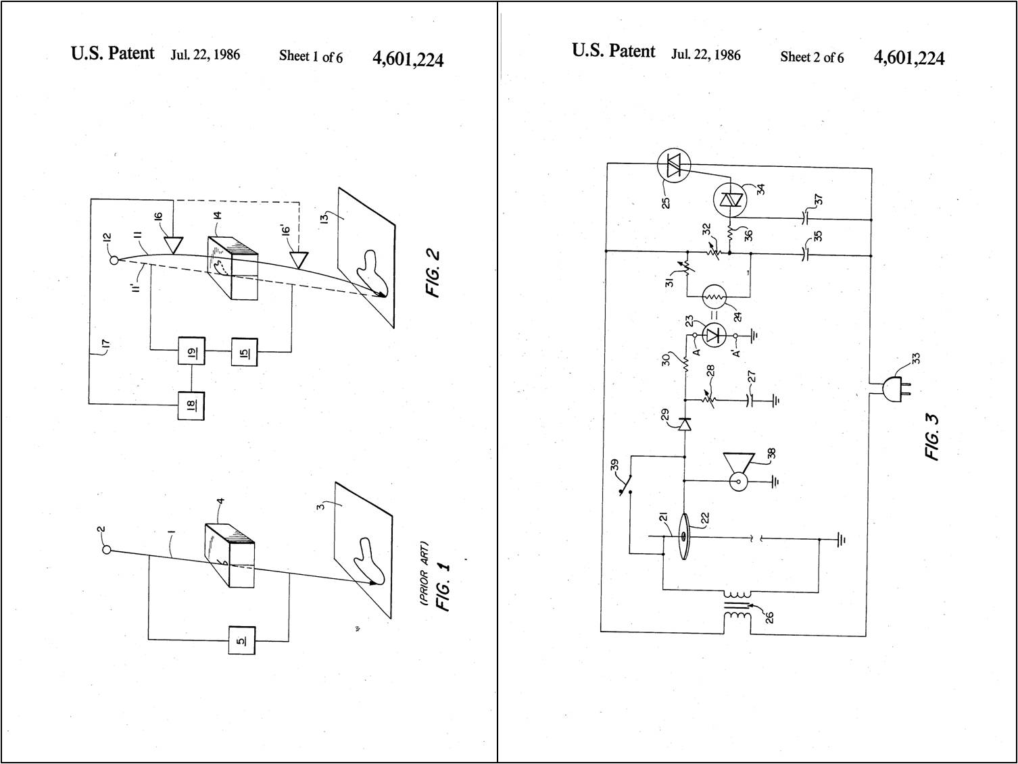

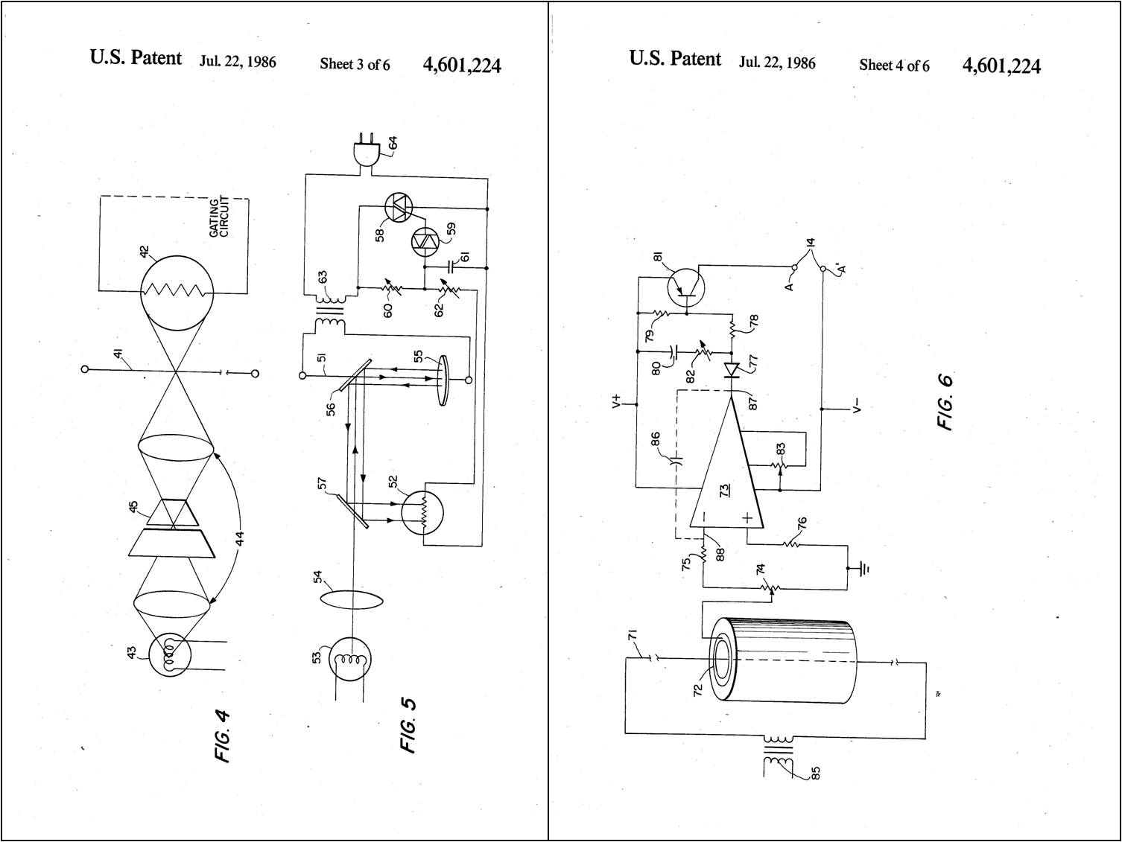

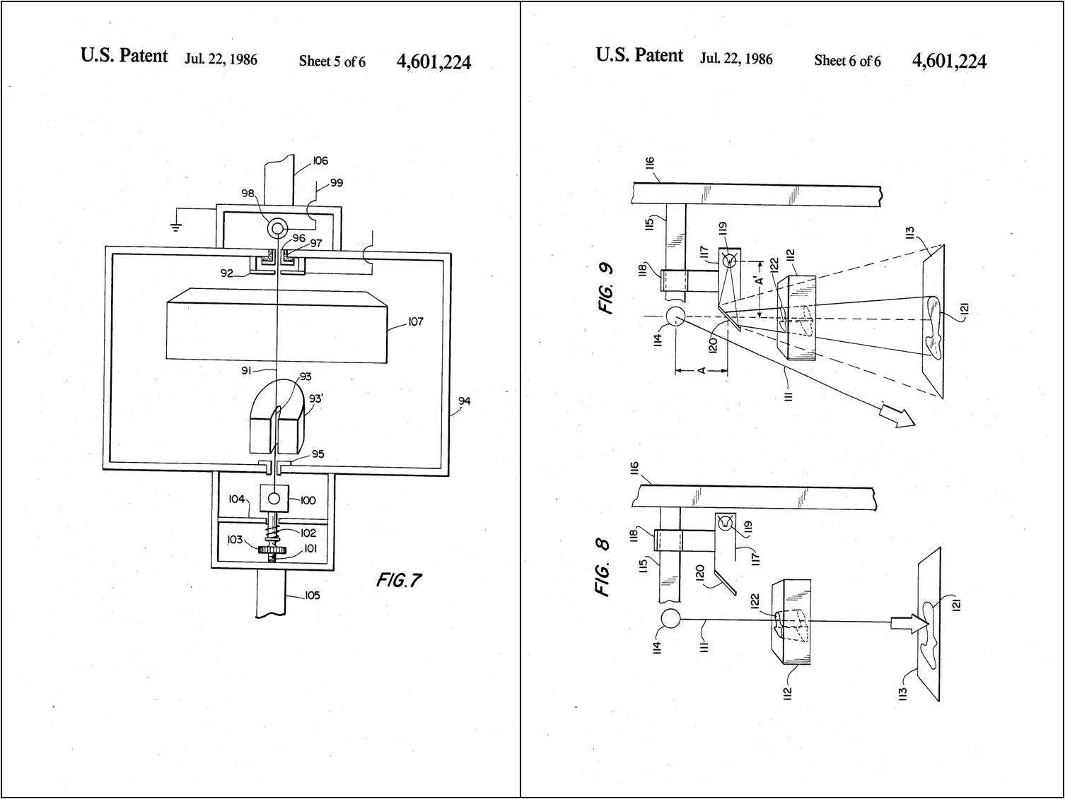

Figure 36 2007/04961 'CNC Foam Cutting Machine'[C]

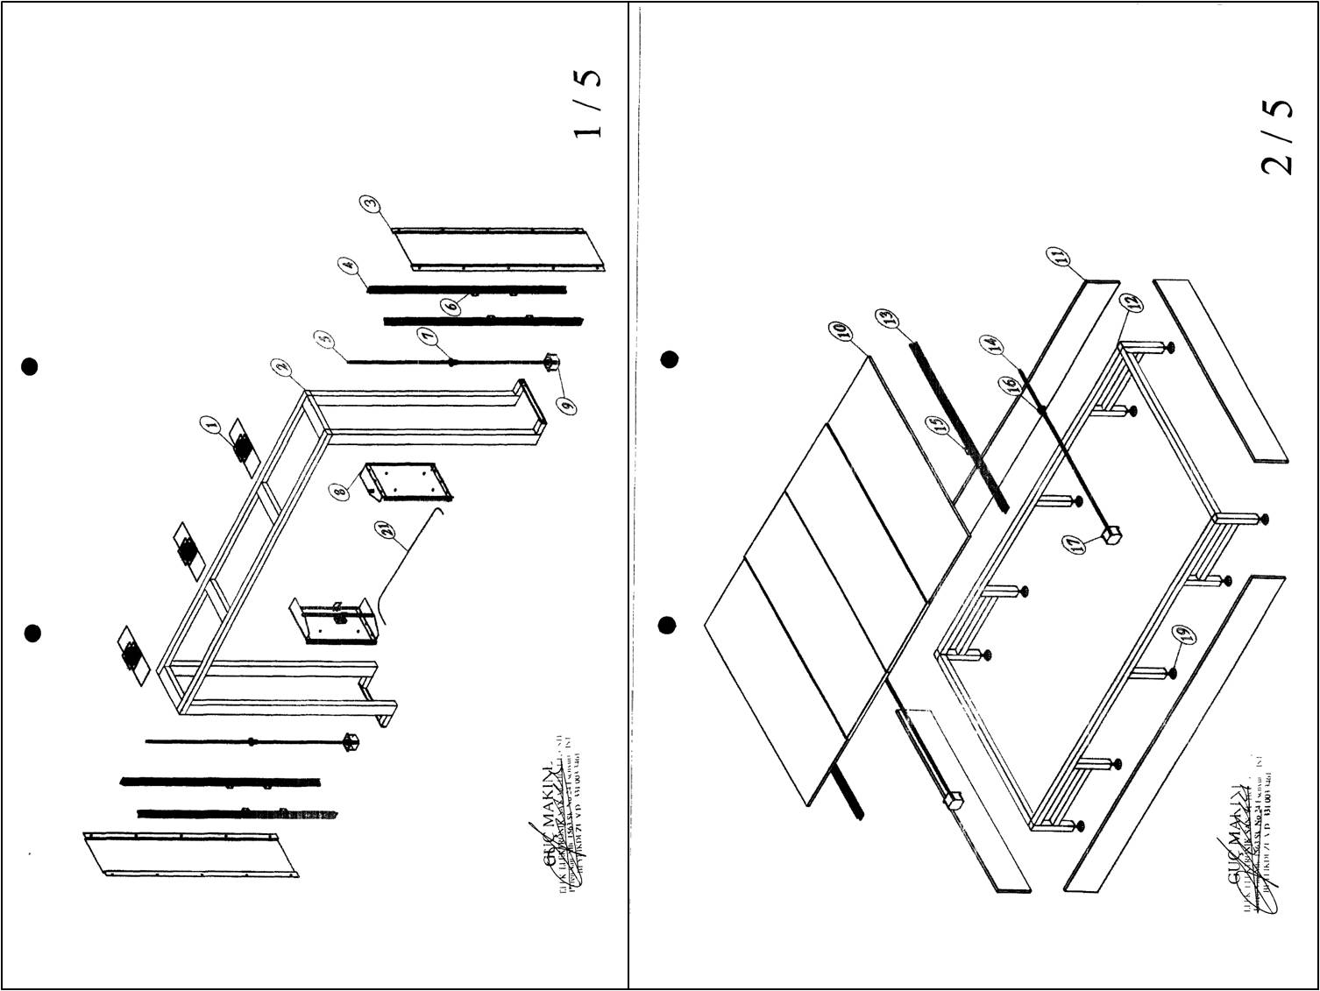

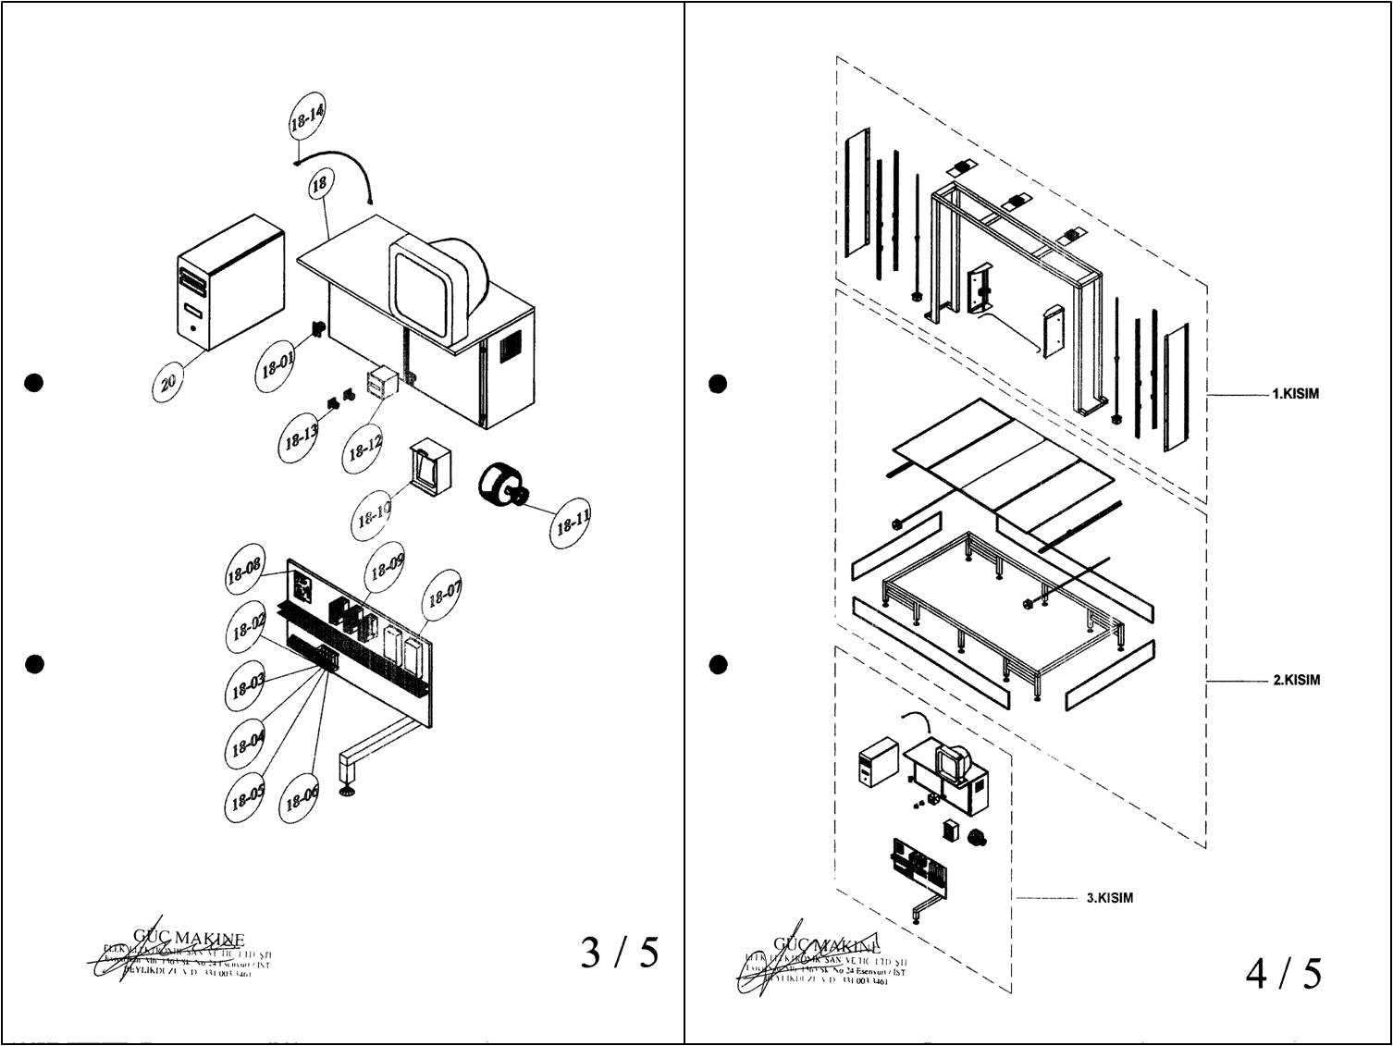

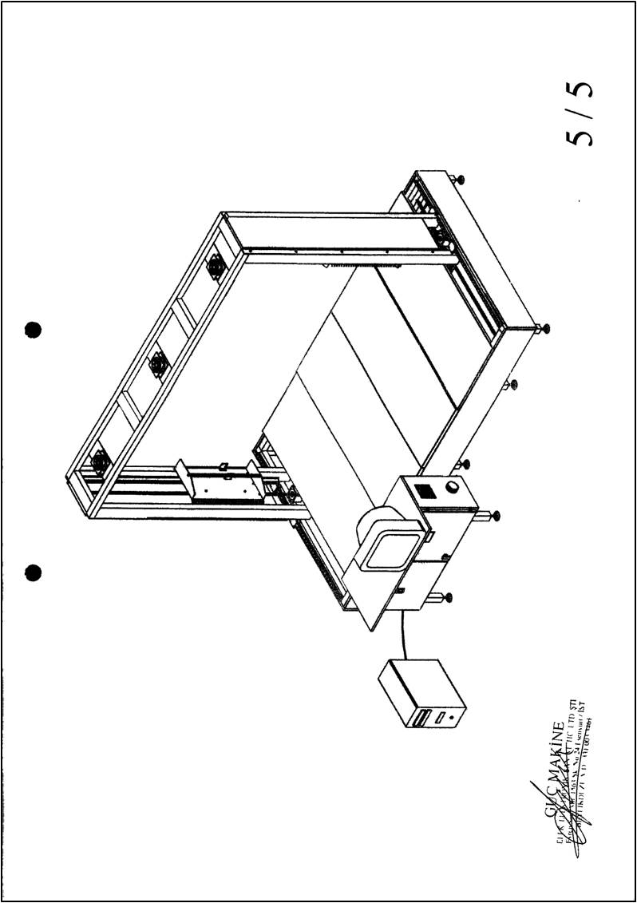

Figure 37 EP2402125A1 'Method of Producing Test Components by a Hot Wire Cutter'[D]

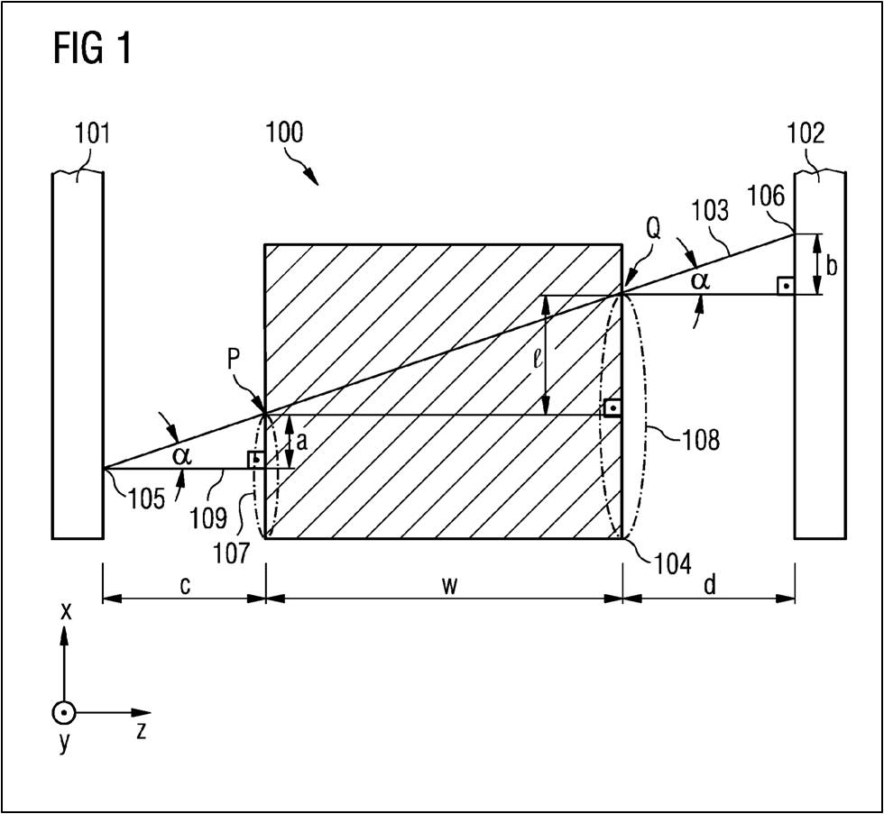

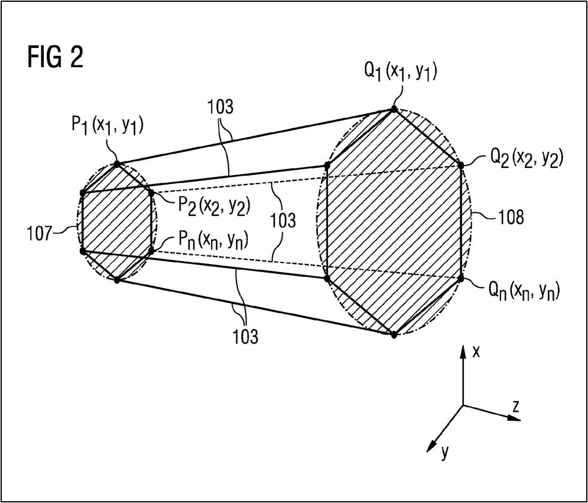

## APPENDIX B: Technical Drawings

